Find the six hidden words

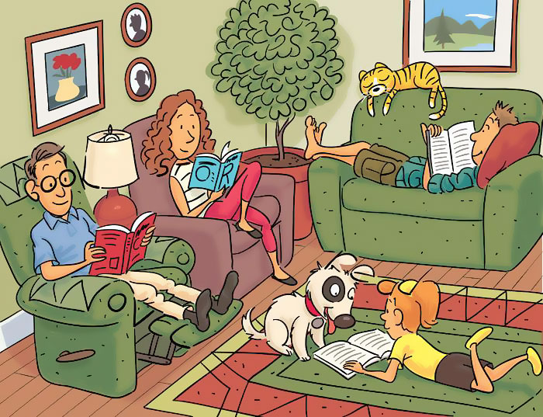

|  |
| --- |
| **The six hidden words** |
|  |
|  |
|  |
|  |
|  |
|  |