6th LEVEL WEEK 1st-7th JUNE


www.k5learning.com

Objective sight words (refreshment, grab, groceries, continues, arranged, apprentice, caramels, expand, convention, equipment, focused, afford); concepts (Hershey, Pennsylvania; successful business, steps to make chocolate, foundation)

Vocabulary

refreshment caramels
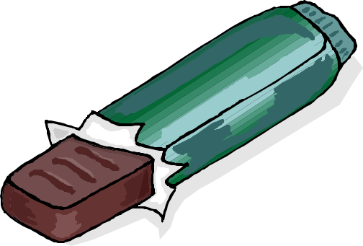

grab expand

groceries convention

continues equipment

arranged focused

apprentice afford

The History of Chocolate

By: Sue Peterson

People from all over the world like the taste of

chocolate. Chocolate is a refreshment that many people enjoy as a dessert or snack. Did you ever grab a chocolate bar at the store when you were checking out groceries with your mom or dad? Did you ever buy a chocolate bar at the gas station when your parents stopped to buy gas? Did you ever get to pick out a chocolate candy bar at a basketball game or a soccer game?

© Sue Peterson 2012

2
Some people like dark chocolate and some people like

light chocolate. Some
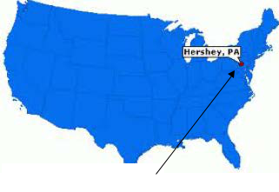

people like plain chocolate

and others like nuts or

cream inside.

Hershey, Pennsylvania

Maybe you have gone to a candy shop that made lots of different kinds of chocolate. Or you might have taken a trip out east and stopped at Hershey, Pennsylvania, where Milton Hershey first made chocolate for Hershey’s candy.

The name “Hershey” is known throughout the world. Milton Hershey died in 1945, but the chocolate factory and Hershey’s chocolate continues to be made in Hersey, Pennsylvania.

Mrs. Hershey thought it would be a good idea for her son Milton to learn a business from someone who was a successful businessman. So when Milton finished fourth grade, she arranged for Milton to become a printer’s

© Sue Peterson 2012

Milton Hershey
3
apprentice where he would learn about print, newspapers, and books.

However, Milton did not like this kind of work and soon he was serving as an apprentice under his father who got a new job in a candy factory where he helped to make candy.

After a few years, Milton knew that he was a good
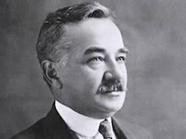

candy maker and he wanted to start his own candy business. He tried to build several businesses in many different cities, and he did

not give up until his candy business was finally a success. He learned to make caramels and to expand the kinds
of candy he made. When he was 29-years-old, he moved back to Pennsylvania to start a caramel business, and in four years his business was very successful.
After seeing how chocolate was made at a chocolate convention, Milton purchased the equipment needed to make similar chocolates. He got married and sold the

© Sue Peterson 2012

4
caramel company for $1,000,000 dollars and opened up a chocolate factory.

Hershey built an entire town complete with houses, schools, churches, and stores so the people who worked in his factory could live nearby. The Hershey Chocolate Company grew to make sweet chocolate and cocoa.

He focused his factory on the “nickel bar”, a chocolate bar that everyone could afford. He then added Hershey Kisses and Hershey’s with Almonds.
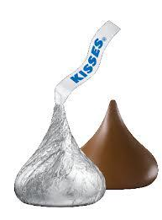
As success and profits rose, he expanded his town to add a sports arena, a stadium, and a school to learn how to make chocolate. The school was for orphaned children, and when

his wife died, Milton took all of his money ($60 million dollars) and gave it to the school to help these children.

He also made a foundation which is an organization that gives money to people who need it. His foundation is designed to help people get an education.

© Sue Peterson 2012

5
Milton Hershey died in 1945, but the world remembers him for not only making chocolate bars, but for his work to help people through his foundation. A medical center for The Pennsylvania State University was also founded.

Milton Hershey is remembered as someone who built an entire city and helped people get jobs. He is remembered for someone who made a school for children who did not have families. He is someone who made a medical center to help those who are sick and someone who made that chocolate, that yummy chocolate that most of us throughout the world enjoy.
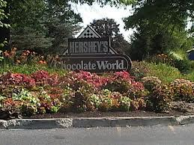

Hershey’s Chocolate Company

© Sue Peterson 2012

6
Practice

Multiple-Choice Questions (Put an X in front of the correct answer.)

- The word “apprentice’ is described in the text. Who is most likely an apprentice?

 a. A teacher who teaches reading at school.
 b. A parent who cooks dinner at your house.
c. A friend who bikes with you to the park.
 d. Someone who learns a trade from someone who is skilled.

- Hershey, Pennsylvania, is a famous town. Which of these does not describe the town of Hershey?
a. houses, schools, churches, and stores
b. sports arena
c. stadium
 d. ice rink

- According to the text, what was the town of Hershey designed to do?

a. offer a school and jobs for orphaned children
b. add a city to Pennsylvania
c. to make nutritional, low-calorie food
d. all of the above

- Hershey’s chocolates are eaten throughout the world. Which of these describe the variety of chocolate that is made?

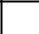 a. dark chocolate
 b. light chocolate

c. plain chocolate
d. chocolate with nuts
e. chocolate with cream
 f. all of the above
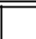 g. none of the above

© Sue Peterson 2012

7
Definitions (Write the meaning of each word as it is used in the text.)

- continues

- apprentice

- expands

Extended Response (Answer in complete sentences.)

- Why do you think Milton Hershey gave funds to the orphan school and made a foundation when his wife died?

_____________________________________________________

_____________________________________________________

_____________________________________________________

_____________________________________________________

_____________________________________________________

_____________________________________________________

_____________________________________________________

_____________________________________________________.

© Sue Peterson 2012

8
- How will Milton Hershey be remembered?

_____________________________________________________

_____________________________________________________

_____________________________________________________

_____________________________________________________

_____________________________________________________

_____________________________________________________

_____________________________________________________.

- Who likes chocolate in your family? What kind is their favorite and why?

_____________________________________________________

_____________________________________________________

_____________________________________________________

_____________________________________________________

_____________________________________________________

_____________________________________________________

_____________________________________________________

_____________________________________________________

_____________________________________________________.

© Sue Peterson 2012

-Song: Our partner Zoe says her favourite song is Problem from Ariadna Grande. You can Practise it with lyrics training.
https://es.lyricstraining.com/play/ariana-grande-iggy-azalea-big-sean/problem/HrcQjK5S8r#b7w

© Sue Peterson 2012

This story is an excerpt from a levelled reading workbook available at store.k5learning.com/reading-comprehension

