5th and 6th LEVEL 20th APRIL
Hello. This is what I propose to you this week.
Remember! Pots enviar-me les activitats que facis al mail joanmaragallenglish@gmail.com o guardar-les (llibreta, carpeta, pendrive,…) per entregar-me-les quan tornem a l’escola.

1-Watch these 2 videos:

Valdo in Haiti

https://subscription.oneglobekids.com/view-friend/1

Luna in New York City

https://subscription.oneglobekids.com/view-friend/3

2-Then, answer the questions that Valdo and Luna ask to you:

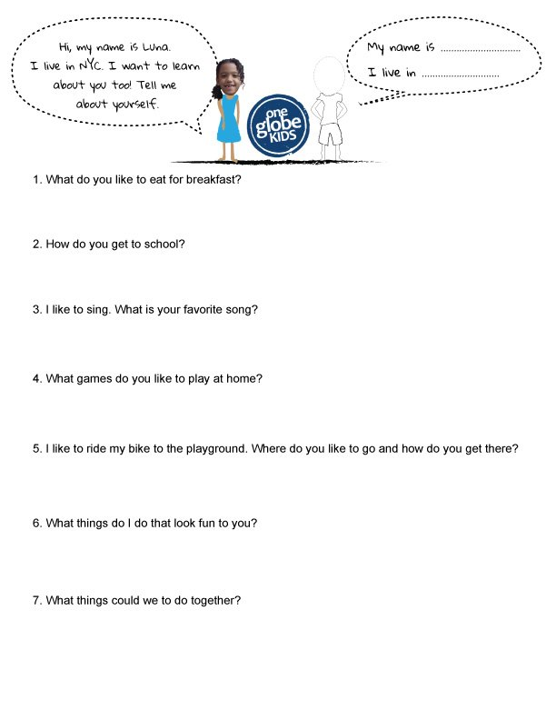
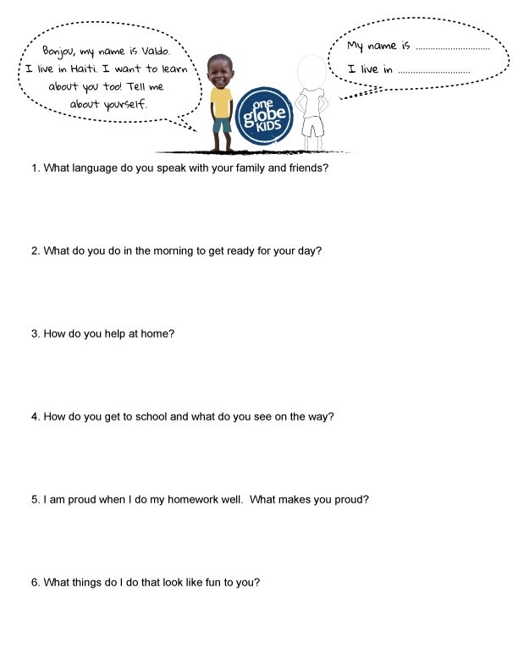

3-Make a poster: 

4-Make a PowerPoint about Lleida, Catalonia, Spain o another country, (pots seguir com a model l’apartat Facts about Haiti or New York City, com al vídeo del Valdo i la Luna).

