
PARTICIPANTS
22è Repte

CHAIMAE
NIL
ANELEY
BIEL
ANDRÉS
ALMA

PAU
FATIMA ZOHRA
LUCÍA
WISSAL
JON
AMIN


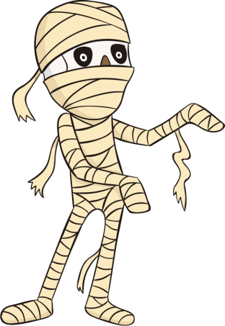
MANUEL
FRAN
WIAM
AICHA
LIAM
OUMNIA
AXEL
SARA
HIND
AMIN
MARC
MOHAMMED
JÚLIA
DOHA
VALENTINO
QUERALT
ASMA
VICENÇ



AMIR
NEREA
DAVID
RAWAN
EDÉN
MIRANDA
ADAM
AINARA
JAIME
DOUAE
ANGEL
PABLO



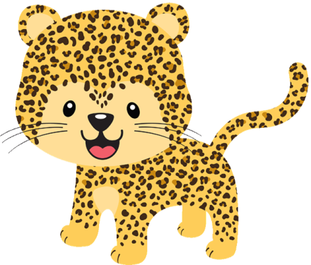

ARNAU
ENZO
HAJAR
HARITZ
ERIK
INARA
SOHAILA
MANUELA
ROSA
ALEJANDRO
REDA

