
PARTICIPANTS
20è Repte


PAPALLONES
ANELEY
CHAIMAE
NIL
BIEL
ALMA
YAIZA
JOEL
ADONAI
ADARA
BRIANA
IAN
ANDRÉS


QUERALT
DOHA
AMIN
MARC
DÁMARIS
AARON
LIAM
VICENÇ
SARA
AICHA
ASMA
MANUEL
JÚLIA
MOHAMMED
FRAN
OUMNIA
AXEL



JON
IKER
PAU
ALEJANDRO
FATIMA Z
DAVID

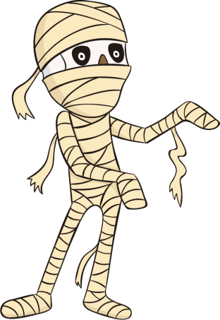

ANGEL
PABLO
EDÉN
JAIME
DOUAE
NEREA
DAVID
MIRANDA
AMIR



