
PARTICIPANTS
19è Repte


PAPALLONES
ANELEY
CHAIMAE
NIL
BIEL
ALMA
YAIZA
JOEL
ADONAI
ADARA
BRIANA
IAN
ANDRÉS

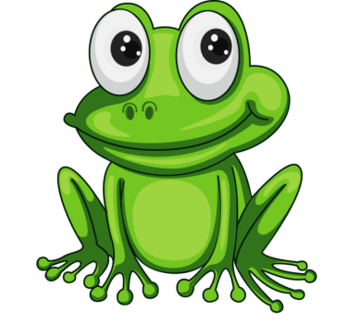
WASSIM
AYOUB
INARA
REDA
ROSA
JUAN
ALEJANDRO
HARITZ
LUCA
HAJAR
ENZO
SOHAILA

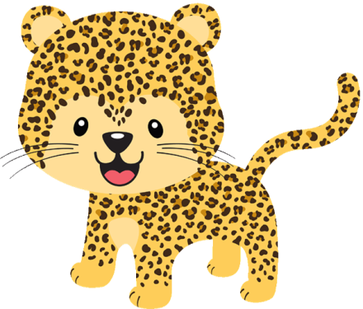

SARA
MANUEL
DILAN
VALENTINO
QUERALT
LIAM
FRAN
DOHA
MARC
AICHA
AXEL
ASMA
HIND
MOHAMED
AARON
WIAM
JÚLIA
OUMNIA
VICENÇ
AMIN
JÚLIA



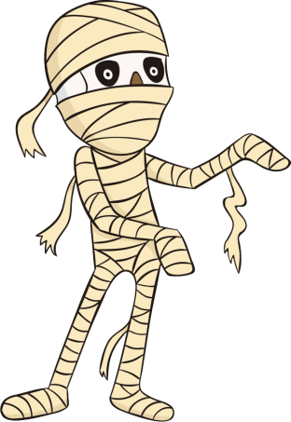
LEYRE
OLAIA
ALEJANDRO
WISSAL
DAVID
ALUMINE
LUCIA
IKER
ALEJANDRO



NEREA
PABLO
DOUAE
JAIME
MIRANDA
RAWAN
AINARA
EDÉN
DAVID

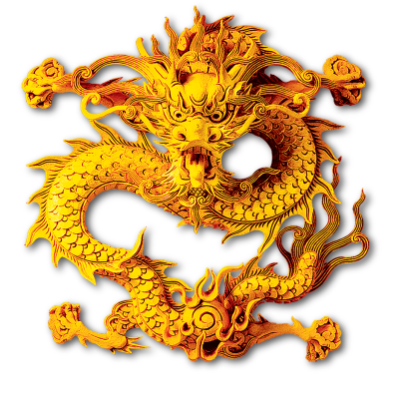

NAGORE
NOA
ROCÍO
YUMARA
WIAM
BRUNA
AVRIL
LEO
THAIS
RANIA
AYOUB

