
PARTICIPANTS
18è Repte


PAPALLONES
ANDRÉS
NIL
ADARA
CHAIMAE
JOEL
ANELEY
MOUSSA
ALMA
YAIZA
HARON
ADONAI
BRIANA
IAN



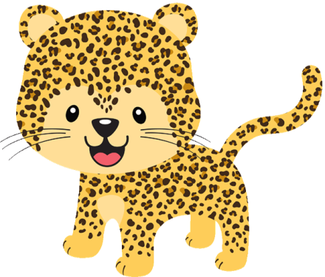
SOHAILA
DANIEL
HARITZ
YANNICK
DOAA
HAJAR
AYOUB
ENZO
INARA
MANUELA
REDA
ERIK
ABEL
BARAE
GABRIEL
LUCA
ROSA



AXEL
ASMA
SARA
FRAN
MARC
HIND
OUMNIA
JÚLIA
AICHA
VICENÇ
MANUEL
MOHAMED
QUERALT
AARON
AMIN



JAIME
NEREA
EDÉN
DAVID
PABLO
DOUAE
AINARA

