
PARTICIPANTS
11è Repte


PAPALLONES
BIEL
JOEL
ADARA
ANDRÉS
YAIZA
MOUSSA
IAN
ALMA
ANELEY
HAARON
BIEL
DOAA
ARNAU
ENZO
HAJAR





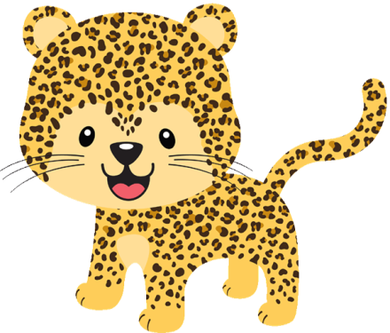

YANNICK
WASSIM
LUCA
ALEJANDRO
MIGUEL
JUAN
BARAE
HAJAR

MARC
FRAN
HIND
MOHAMMED
DOHA
SARA
AMIN
JÚLIA
ASMA
VALENTINO
AARON
LIAM
OUMNIA
AICHA
AXEL
QUERALT


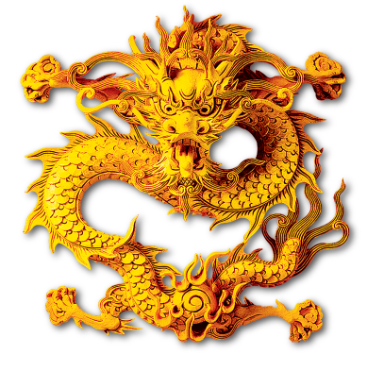
LIAM
OUMNIA
AICHA
AXEL
QUERALT

HANAN
AVRIL
NOA
ISMAIL
RANIA
WIHAM
ROCÍO
BRUNA
YUMARA
JOEL
LEO

