MY NAME IS:
TODAY IS:
JIM AND THE BEANSTALK
1st June-12th June 2020
- Watch the video about the tale of Jim and the Beanstalk.
https://www.youtube.com/watch?v=OVVLBK1350o&feature=youtu.be
- Write the name of these objects.
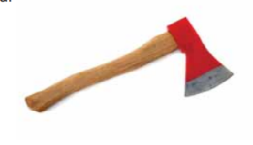 | 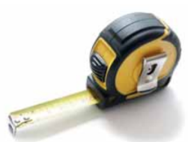 | 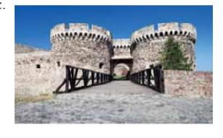
1 | 2 | 3
 | 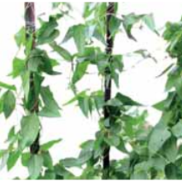 | 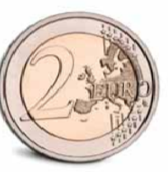
4 | 5 | 6

TEETH
AXE
BEANSTALK
COIN
CASTLE
MEASURE TAPE
- Draw your favourite part of the story:

My favourite part of the story is…………………………………..

