My name is:
Today is:
- Watch the video about THE FISH THAT WANTED TO BE BEAUTIFUL
https://www.youtube.com/watch?v=fbgmE_-7eok&feature=youtu.be
- Match the words to the correct part of the fish.
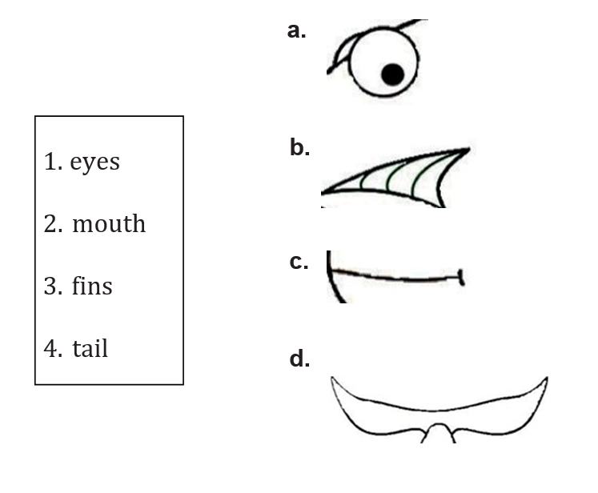
- Colour the parts of the body with the correct colours from the story.
Key: face (orange)
Body (blue)
Fins (green)
Tail (yellow)
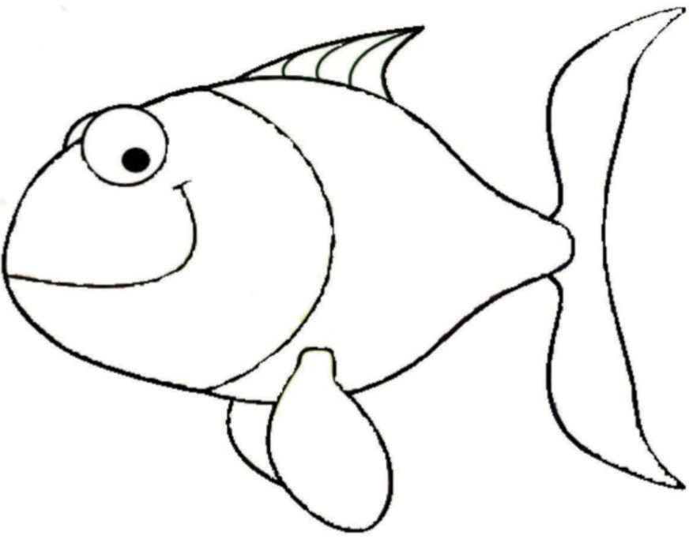
TO REVIEW THE COLORS YOU CAN WATH THE VIDEO WE USE IN CLASS https://www.youtube.com/watch?v=SLZcWGQQsmg

