NAME:
DATE:
3rd GRADE
TASK FROMTHE 4TH TO THE 10TH MAY 2020
- Watch and listen to the tale ‘Room on the broom’ as many times as you need. Do not worry if you do not understand everything, try to understand the main idea of the tale.
https://www.youtube.com/watch?v=XRany_OScms&t=4s
- Match the pictures 1-6 to the words a-f.
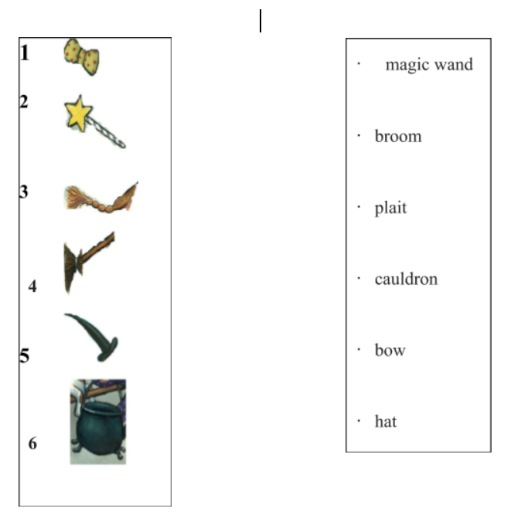

- Draw a picture of the witch on the broom and colour it with your favourite colours. Complete the sentences with a colour to describe your witch.
MY WITH

My witch has got a……………………………………plait.

My witch has got a …………………………………. hat.

My witch has got a……………………………………bow.

My witch has got a……………………………………magic wand.

My witch has got a…………………………………. broom.

My witch has got a…………………………………cauldron.

Optional If you want, watch to the video and listen to this song. It is very easy to understand.
https://youtu.be/N7AsvmaSNU8

