NAME:
DATE:
FOOD AND DRINK
- Write the number in the right place:

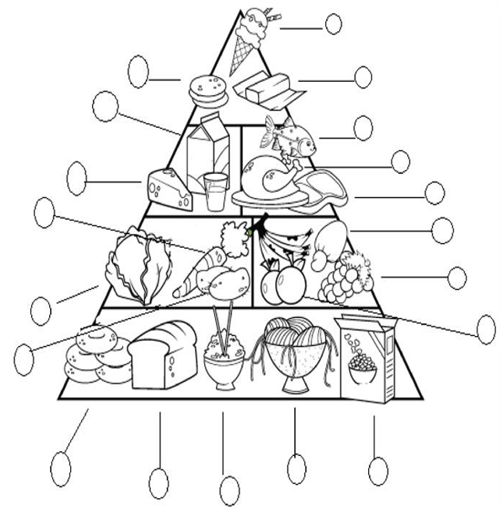
- Pasta | 8. butter | 14. mango
- Fish | 9. cereal | 15. milk
- Bread | 10. oranges | 16. bananas
- Ice-cream | 11. carrots | 17.potatoes
- Rice | 12. steak | 18.cheese
- Lettuce | 13. grapes | 19.nuts **
- chicken |  | 20. Hamburger

- fruits secs
Remember that you have a PowerPoint in the school web site.
- Now, put a tick ( ✓) or a cross (✗) and write 9 sentences using I like, I don’t like: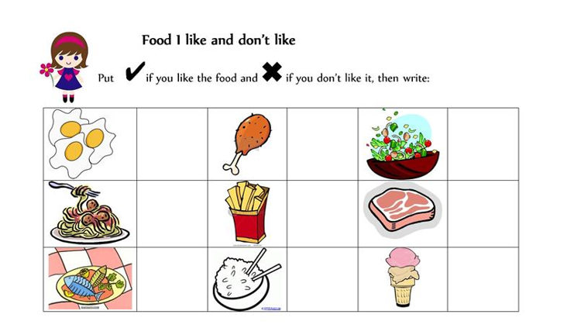

Things you like

Things you don’t like

