Hello class, this is my proposal for this week. It’s a story about some animals and their characteristics.
First you can watch and listen to the story as many times as you need. To do this, copy the link and paste it in an internet searcher.
And then you can do the activities. Don’t forget to write your name and the date. Do you remember? Today is Thursday, the 2nd of April 2020 (it’s an example).
See you soon.
Hola classe, aquesta és la meva proposta per aquesta setmana. Es tracta d’una historia sobre alguns animals i les seves característiques.
Primer, podeu mirar i escoltar la historia les vegades que calgui. Per fer-ho, heu de copiar el link i enganxar-lo en un buscador d’internet.
Després podeu fer les activitats. No us oblideu de posar el vostre nom i la data. A Dalt teniu l’exemple, tal I com ho hem treballat a classe. Today is Thursday, the 2nd of April 2020
Fins aviat.

https://www.youtube.com/watch?v=l5w2mPdaNVc
( Macmillan Story Corner, Mr crocodile’s toothbrush )

NAME:
DATE:
MR CROCODILE’S TOOHBRUSH
- Match the animals to the words:

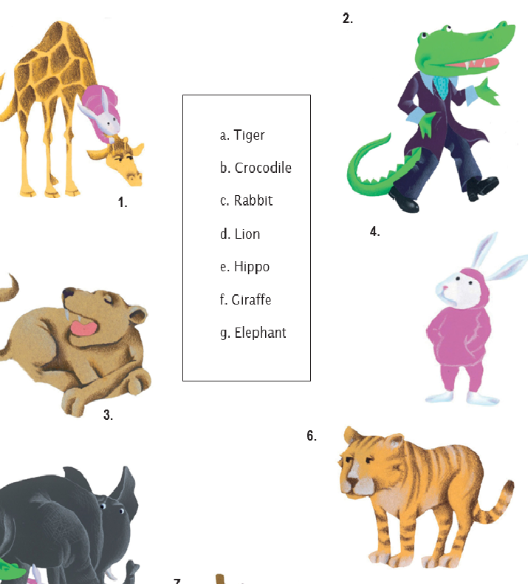

- What’s your favourite animal? Draw your favourite animal and then write a sentence. Example: My favourite animal is the dolphin.

