Hello class, this is my proposal for this week. It’s a story about a peculiar animal, a GRUFFALO.
First you can watch and listen to the story as many times as you need. To do this, copy the link and paste it in an internet searcher.
And then you can do the activities. Don’t forget to write your name and the date. Do you remember? Today is Thursday, the 2nd of April 2020 (it’s an example). See you soon.
Hola classe, aquesta és la meva proposta per aquesta setmana. Es tracta d’una historia sobre un animal molt peculiar, un GRUFFALO.
Primer, podeu mirar i escoltar la historia les vegades que calgui. Per fer-ho, heu de copiar el link i enganxar-lo en un buscador d’internet.
Després podeu fer les activitats. No us oblideu de posar el vostre nom i la data. A Dalt teniu l’exemple, tal I com ho hem treballat a classe. Today is Thursday, the 2nd of April 2020
Fins aviat.
https://www.youtube.com/watch?v=ET8_OSlmW68&t=18s
( Macmillan story corner The Gruffalo )

NAME:
DATE:
THE GRUFFALO
- Number the animals in the order the appear in the story:
Mouse: 1
The Gruffalo:
Owl:
Snake:
Fox:

Draw your favourite animal from the story here:

- What colour? Read, write and colour:
Purple Orange Black

- The Gruffalo has…………………………………. eyes.

- The Gruffalo has a …………………………. tongue.

- The Gruffalo has……………………. prickles on his back.

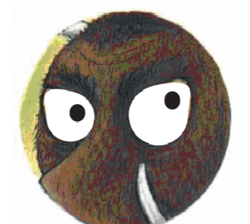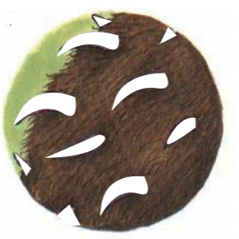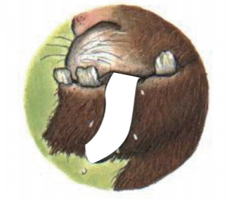
eyes
prickles
tongue

