**CEIP Carles de Fortuny**

**NAME:…………………………………… Worksheet 1**

**THERE IS (hi ha) / THERE ARE (hi ha més d’un)**

**COMPLETE THE SENTENCE WITH THE CORRECT FORM:**

1. There ___are__________ many (molts) animals in the zoo.

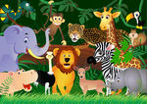2. There _____________ a snake in the window.

3. There _____________ a zebra in the grass (herba).

4. There _____________ lions in the zoo, too.

5. There _____________ many baby lions.

7. There _____________ many monkeys in the trees.

8. There _____________ an elephant in the zoo.

9. There _____________ some water in the lake.

10. There _____________ birds in the zoo.

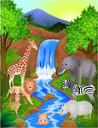11. There _____________ many people (gent).

12. There _____________ many children, too.

13. There _____________ a gorilla in the tree.

14. There _____________ some grass under the tree.

15. There _____________ bananas in the tree with the gorilla.

16. There _____________ many birds near the gorilla.

17. There _____________ a rock near the tree.

18. There _____________ many sharks in the aquarium.

19. There _____________ a fish in the aquarium, too.

20. There ______________lots of water for the fish.

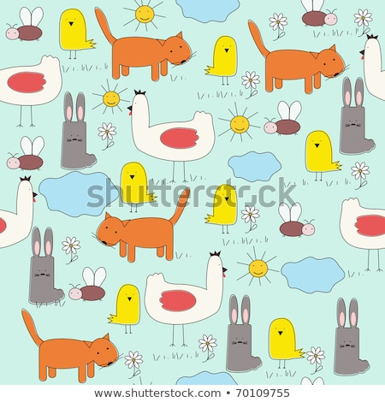

1. How many yellow birds are there?

***There are 6 yellow birds***

1. How many rabbits are there?
2. How many cats are there?

YES, THERE IS / YES, THERE ARE

NO, THERE ISN’T / NO, THERE AREN’T

1. Is there a dog?
2. Are there any bees in the photo?
3. Are there any red flowers?