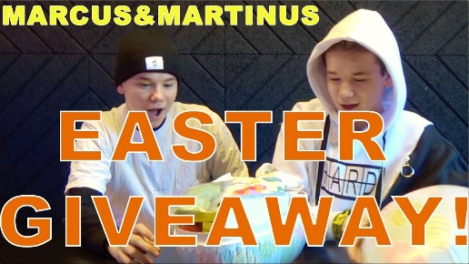
MARCUS AND MARTINUS
UNBOXING A HUGE EASTER EGG

FILL IN THE BLANKS
DINOSAUR SODA CHARGER OPEN CHOCOLATE CANDY WINTER
It’s an Easter ........................... egg and Marcus and Martinus .........................it.
They take out a ........................that people drink in...................... The egg’s got
a typical Swedish ................ and a ........................This is the best .......................you can get!

T-SHIRT EGGS BLACK MARK MASK TELESCOPE FAVOURITE COOL
It’s got some strange stuff! It’s got a lip ......................... and Easter ..........................
Oh! A Marcus and Martinus’……………………! It’s my ................................ It’s really………………….
Wow! A black eye ................................................, when you take it out, you get a
..............................................around your eye.

PUT INSTRUCTIONS STICKERS HAPPY INSTAGRAM STUFF CARD BIG EGG
We gonna ........... this...................back here to get together again. It’s got
some .................................and an Easter………………………. It says “...........................Easter”
If you want to win this egg, you have to go to our ..................................called
“Marcus and Martinus” and follow the.......................................down below and
find the picture where we have the .......................................
See you guys soon! Peace out! Bye!
By………………………………

