WHAT TO DO DURING THIS CONFINEMENT

PLAY BOARD GAMES WATCH A FILM
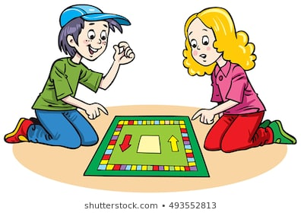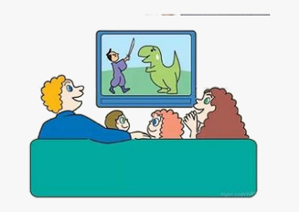

COOK A RECIPE CALL YOUR FRIENDS AND FAMILY
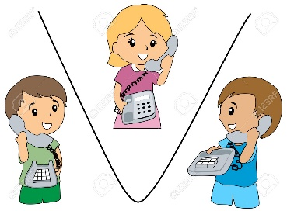

READ A BOOK DANCE PARTY

TREASURE HUNT CREATE A MOVIE

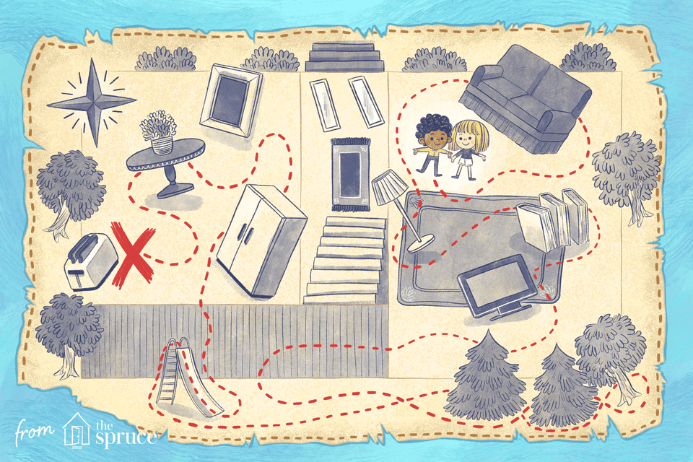
WRITE AN E-MAIL TO A FRIEND LISTEN TO MUSIC

PAINT OR COLOUR MAKE A PUPPET
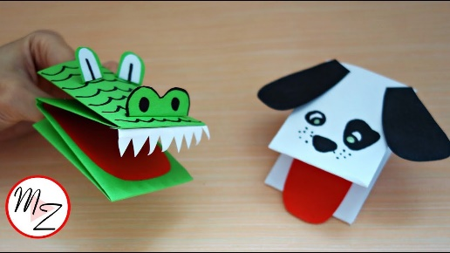

CHANGE THE LYRICS OF A SONG PRACTICE ORIGAMI
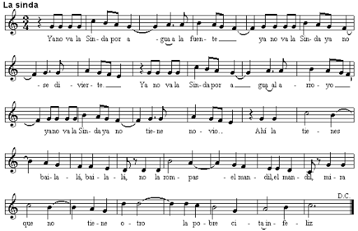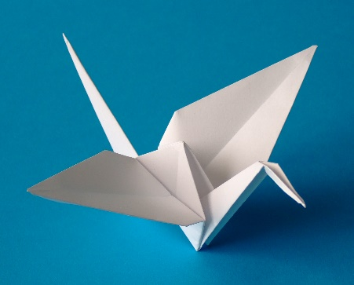

DO A JIGSAW DRAW YOUR OWN COMIC
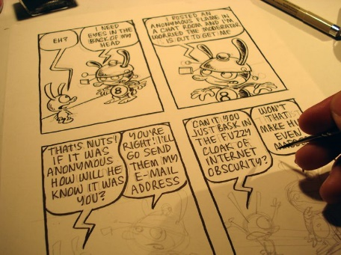

RESOURCES:
www.gamestolearnenglish.com
www.agendaweb.org
www.english-room.com
Videos a youtube: wow english tv (songs and stories)
Navio Macmillan

Us animem a compartir amb la resta de companys/es i amb nosaltres les coses que aneu fent a través de una foto, un video, el mail..

