English Activity 4
Markets started in the ancient civilizations, let’s discover more about it!
PROJECT CIVILIZATIONS
- Go to blinklearning and click on Project project webside 6
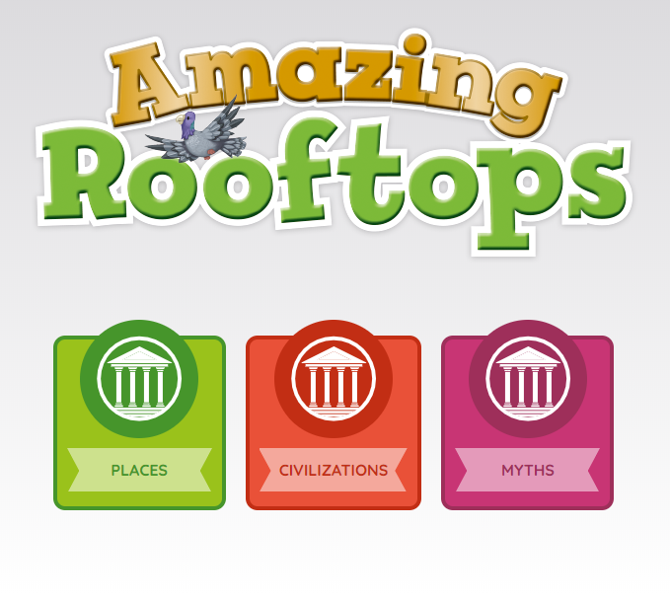
- Click on CIVILIZATIONS

1. Listen and Read. Then answer the questions.

ANCIENT CIVILIZATIONS
- What’s the name of the person who find out about life in the past?

- What are the two ancient civilizations of the project?

INCA EMPIRE
- Where did the Inca Empire live?
- What was the capital of Inca Empire?

- How did the Inca call the clans?

- what did the Inca believe about the gold?

- What did people eat?

ANCIENT GREEKS
- When did the Ancient Greek civilization begin and end?

- What is a slave?

- Ancient Greeks went to work as …………..

- What did they use to write?

- What did men wear? and women?

What is your favourite ancient civilization?

2. Activity Book
Pages 44 and 45: ex. 1,2 and 4
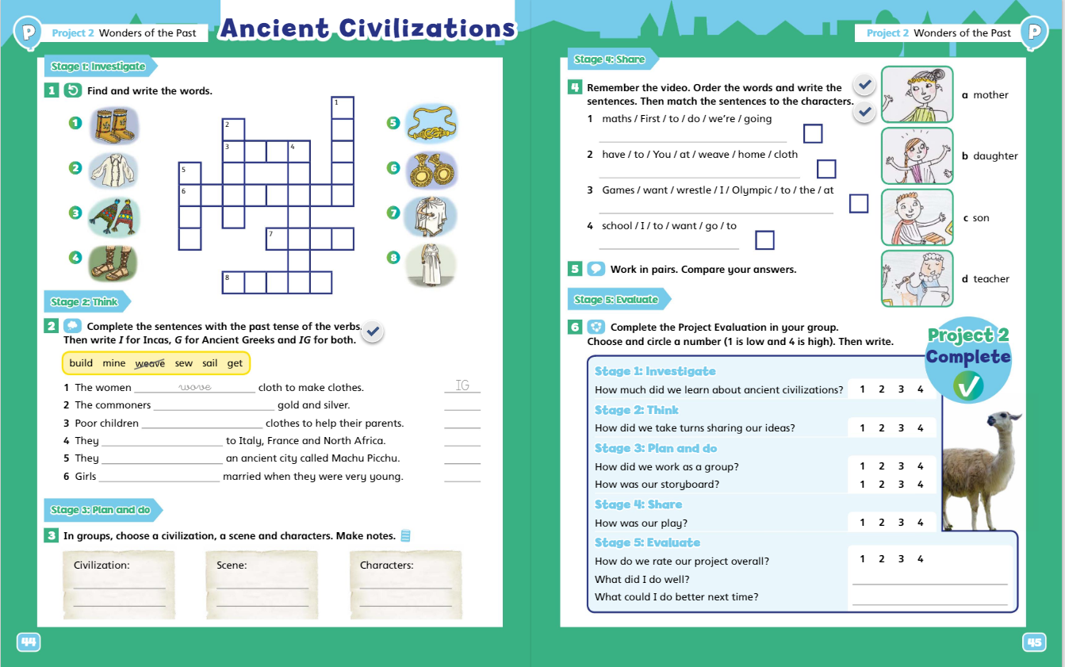

3. I-PROGRESS CHECK 2
Do the 9 exercises of i-progress check 2.
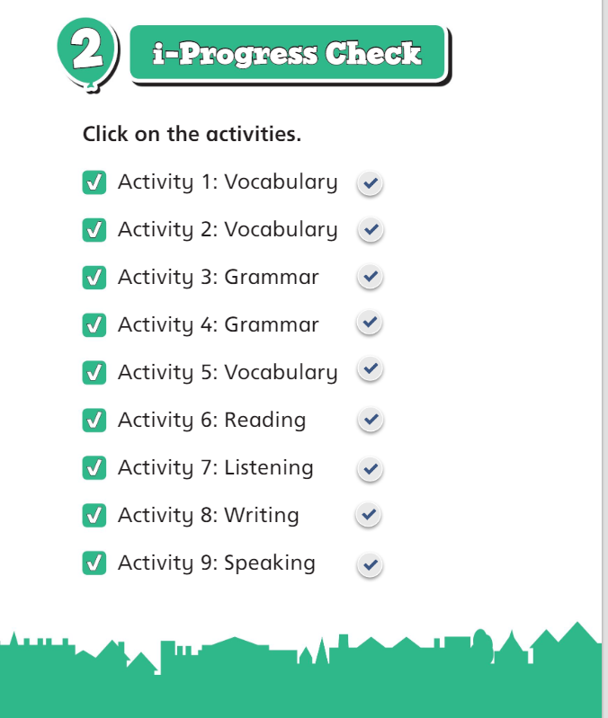

ENTREGA
Tens fins el dia 8 de juny per entregar les activitats:
- L’activitat 1 l’has d’enviar per correu electrònic amb un word o una foto si ho fas a mà.
- L’activitat 2 de l’activity book fes-la al mateix llibre i en fas una foto. (en boli es veu millor)
- L’activitat 3 és autocorrectiva.
Correu: bgil5@xtec.cat
Assumpte: Activity 4 English (el teu nom)

AUTOAVALUACIÓ
Completa la taula posant la data, una creu a la casella d’autoavaluació que et sembli i comenta què t’ha semblat en l’apartat d’observacions.

 | ACTIVITAT | DATA | AUTOAVALUACIÓ |  |  | OBSERVACIONS
 | ACTIVITAT | DATA | No l’he pogut acabar | M’ha costat | L’he acabat molt bé | OBSERVACIONS
1 | Project
2 | Activity book
3 | i-Progress check 2

