English Activity3
1.PROJECT PLACES : Go to blinklearning and click on Project project webside 6 (llegeix les Instruccions project pdf)
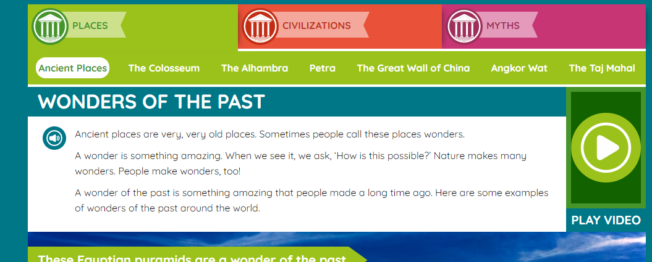
1. Watch the video of the project places

2. Listen and Read the Places. Don’t miss the “Amazing fact!”
3. Answer the questions.
Ancient Places
- How people call the very old places?

The Colisseum
- What did the ancient romans watch in the Collissum?

- What did destroy some of the Collisseum?
The Alambra
- What does Alhambra mean?

- When did people start to build the Alhambra?
Petra
- What was the animal used to transport people and things?

- Petra is located in the desert in .

The Great Wall of China
- Great Wall of China is really many walls. How long are all together?

- How many tourist visit the Great Wall of China every year?

Angkor Wat
- Where is Angkor Wat located?

- What animal can you find running around Angkor Wat?

The Taj Mahal
- What is Taj Mahal?
  - A palace
  - A tomb
- Who are buried in Taj Mahal?

Personal question
What is your favourite Wonder?

2. Activity Book
Pages 24 and 25: ex. 1,2 and 4
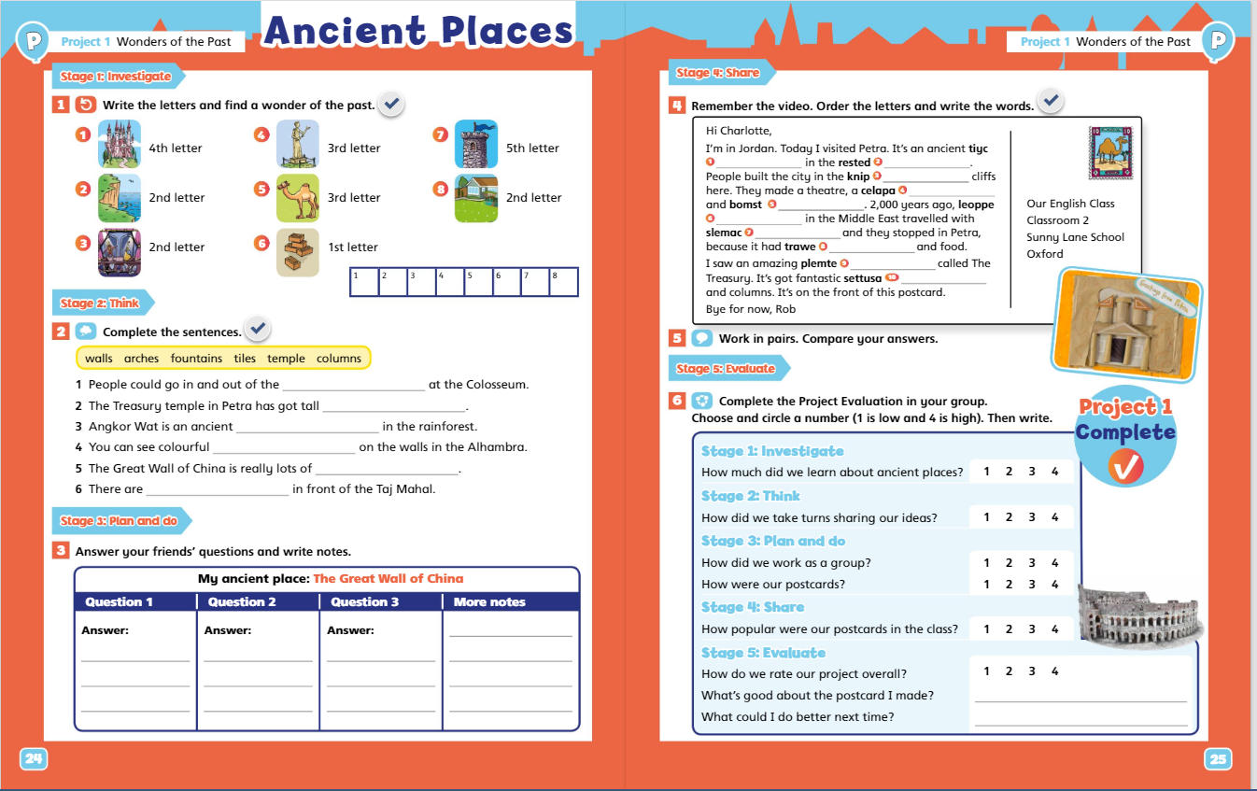

3. Write a letter
An Irish friend is coming to your town for the summer holidays. He wants to know about you and about your town. He sent you this email:
Hello,
My name is Alexander. I am coming to your town next summer. I am 21 years old and I live in Cork, Ireland. I am very happy to visit you. We are going to have fun together. Tell me about yourself and your town. What activities can we do? what places can we visit? See you soon, Alexander
Write back to Alexander and tell him about you and your town. Write between 40 and 50 words
About you:
- What’s your name?
- How old are you?
- Where do you live?
About the town:
- What activities you can do in your town. (sports, library,..)
- What places you can visit. (beach, forest, mountain, church, square, shops…)

Hello Alexander,

Good bye.
ENTREGA
Tens fins el dia de maig per entregar les activitats:
- Les activitats 1 i 3 les has d’enviar per correu electrònic amb un word o una foto si ho fas a mà.
- L’activitat 2 de l’activity book fes-la al mateix llibre i en fas una foto. (en boli es veu millor)
Correu: bgil5@xtec.cat
Assumpte: Activity 3 English (el teu nom)

AUTOAVALUACIÓ
Completa la taula posant la data, una creu a la casella d’autoavaluació que et sembli i comenta què t’ha semblat en l’apartat d’observacions.

 | ACTIVITAT | DATA | AUTOAVALUACIÓ |  |  | OBSERVACIONS
 | ACTIVITAT | DATA | No l’he pogut acabar | M’ha costat | L’he acabat molt bé | OBSERVACIONS
1 | Project
2 | Activity book
3 | Letter

