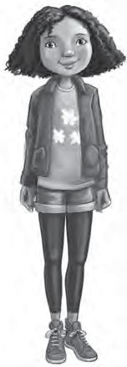
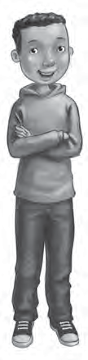
1 Read. Complete the information cards.
Hi! My name’s Ruby Robinson. I’m ten years old. I live in Rooftops. I can play the trumpet.
My favourite animals are parrots. I like computers.
I’ve got a mum, a dad and one
brother. His name’s Dylan. I haven’t got any sisters.
Hello! My name’s Dylan Robinson. I’m nine years old. I live in Rooftops. I can play the recorder.
My favourite animals are gorillas. I like cooking. I’ve got a mum, a dad and one sister.
Her name’s Ruby. I haven’t got any brothers.
Name: Surname: Age:
Live in: Hobbies: Likes: Family:
Name: Surname: Age:
Live in:
Hobbies: Likes: Family:
S

2 Now draw yourself and write.

Hello! My name’s I’m years old.
I live in I can
My favourite animals are I like
I’ve got

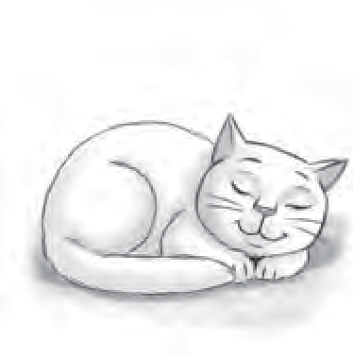
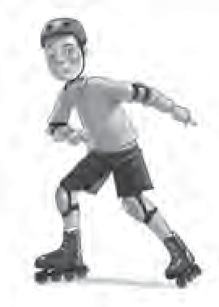
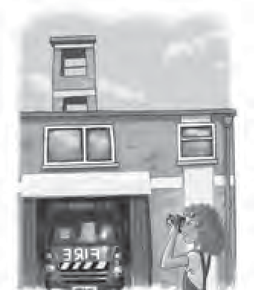
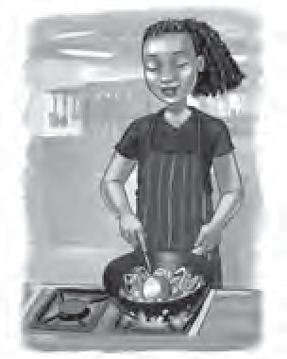
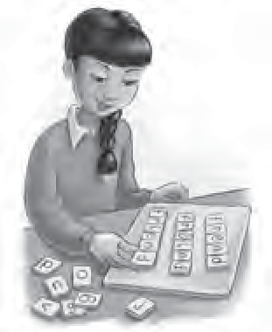
1 Complete the crossword. ₂
1
8
4
5
6
7
7
8
4
5
6
S

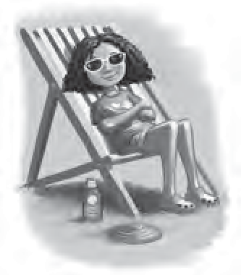
3
1

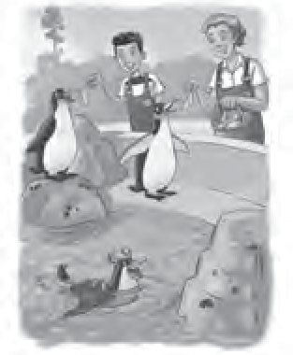
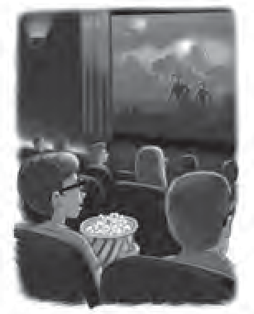
2
3

2 Write the questions. Answer with Yes, I do or No, I don’t.

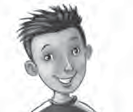

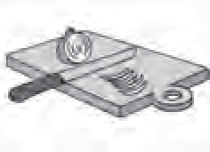
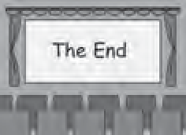
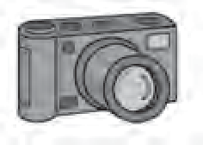
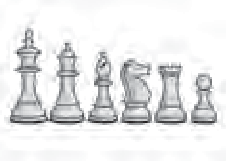
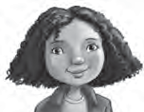
1
Ðo you like taking photos?

2

3

4

5

1 Number.
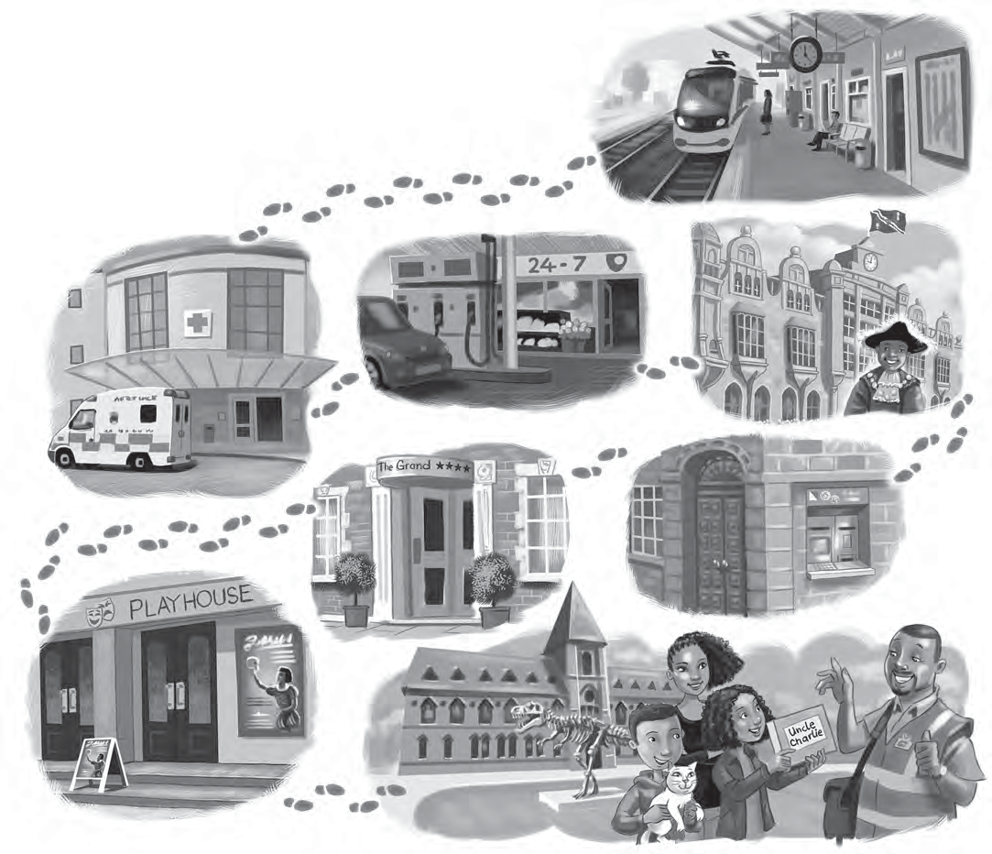
hospital museum petrol station
hotel
town hall train station theatre
bank
1
2
3
4
5
6
7
8

2 Look and answer.
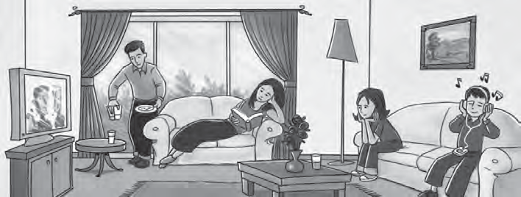
Mum
Eva
Tom

- Is Mum reading a book? yes she is
1
- Is Mum wearing a cap?
- Is Tom listening to music?
- Is Tom buying a drink?
- Is Eva watching a film?
- Is Eva talking to friends?

