ENGLISH 1st graders

- Make a short video tell my what do you like and what you don’t like. Use the pictures about food, to learn the vocabulary. What about you?

What do you like? What you don’t like?
I like….PIZZA I don’t like... PEAR


I like chocolate | I don’t like meatballs
I like chicken | I don’t like carrot

- What is your favourite food? Make a drawing or send me a picture about it. Take a picture of you with your favourite food! Yummy :)
and Write:
My favourite food is FISH and CHIPS, which is typical from ENGLAND.
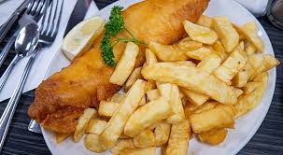

This is my email: safasantacolomaangles@gmail.com send me your tasks, videos, pictures, etc… all you want to share with me. If you prefer you can make a video telling me your answers. Thanks a lot.
Kisses and hugs,
Teacher Myriam

