ESCRIU LA PARAULA. QUIN SO VOCÀLIC HA CANVIAT? PINTA-HO

|  |  |  |
| --- | --- | --- |
| **D** | **A** | **U** |

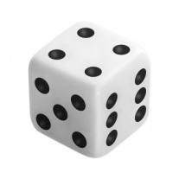

|  |  |  |
| --- | --- | --- |
|  |  |  |

10

|  |  |  |
| --- | --- | --- |
|  |  |  |

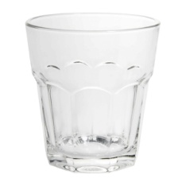

|  |  |  |
| --- | --- | --- |
|  |  |  |

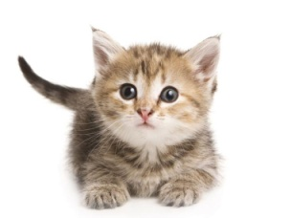

ESCRIU LA PARAULA. QUIN SO VOCÀLIC HA CANVIAT? PINTA-HO

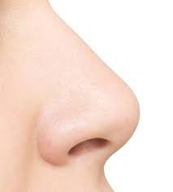

|  |  |  |
| --- | --- | --- |
|  |  |  |

|  |  |  |
| --- | --- | --- |
|  |  |  |

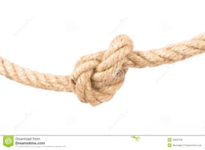

|  |  |  |
| --- | --- | --- |
|  |  |  |

|  |  |  |
| --- | --- | --- |
|  |  |  |

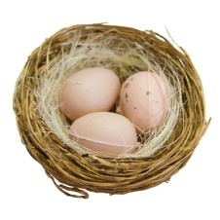

ESCRIU LA PARAULA. QUIN SO VOCÀLIC HA CANVIAT? PINTA-HO



|  |  |  |
| --- | --- | --- |
|  |  |  |

|  |  |  |
| --- | --- | --- |
|  |  |  |



|  |  |  |
| --- | --- | --- |
|  |  |  |



|  |  |  |
| --- | --- | --- |
|  |  |  |

