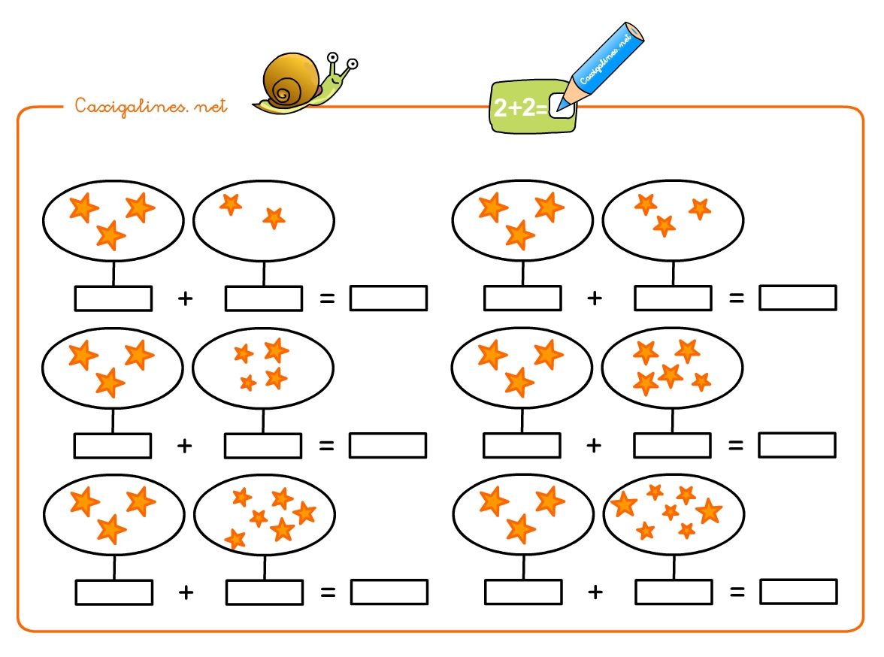

**NOM: ____________________________________________ DATA: _____________________________________________________________________**