Name:

Date: ENGLISH 2nd LEVEL

- Write the word in the correct picture:

windy, sunny, snowy, cloudy, rainy, stormy
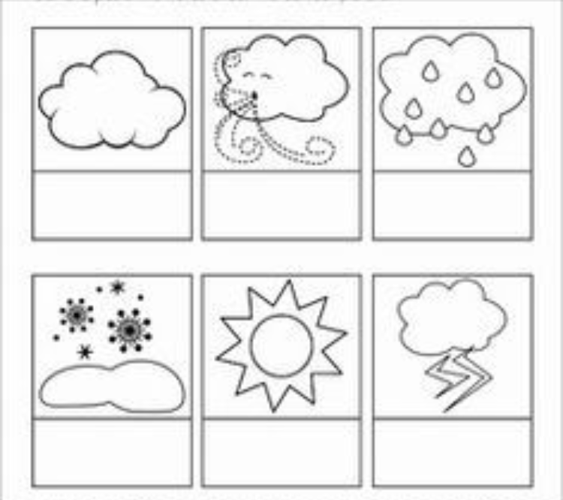

Instructions for the weather cube game!
Cut around the outside. Fold on the lines and tape the sides together to create the cube. Write the words (sunny, cloudy, snowy, rainy and windy) in the correct square.

