WEEK MAY 4th to 8th
ENGLISH
Dear 6th Graders,
Here teacherCarmen! How are you doing? How did you feel last Sunday when you were finally allowed to go out? Did you enjoy your walk along the streets? I imagine you did after 6 weeks locked down at home.
Do you feel like revising a bit of GEOGRAPHY? I attach here the webpage with the QUIZZES that we used to play in class! Feel free to play as many as you want and learn!
Don’t stick to countries and capitals as there are other interesting quizzes to have a look at like for example World Skylines (let’s see if you recognize Barcelona), Wonders of the World and World Country Nicknames (pretty interesting), etc.
https://www.triviaplaza.com/geography-world-quizzes/
Now let’s play some GAMES here. Important → Choose COUNTRIES!
Note: They say America instead of USA and also England instead of UK
https://www.gamestolearnenglish.com/falling-english/
https://www.gamestolearnenglish.com/describer/
https://www.gamestolearnenglish.com/fast-english/
And now time to watch a VIDEO! Put the SUBTITLES to help you understand!
5 Landmarks That Deserve To Be Called The 8TH WONDER Of The World
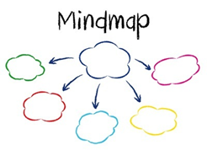
https://www.youtube.com/watch?v=TTU8JqLsaQc
Can you now create a mindmap about the country and the World Wonder?
Thanks,

Bye!
Carmen

