WEEK MAY 25th to 29th
ENGLISH
Dear 6th Graders,
Here teacherCarmen! Let’s play Speedword to keep on practising Irregular Verbs while having fun! Activate FlashPlayer by clicking on the red cross on the right (where you write the name of the webpage) and Allow. (If you don’t know how to do it, ask your parents. Maybe they can help you).
https://www.manythings.org/wbg/verbs_past1-sw.html
https://www.manythings.org/wbg/verbs_past2-sw.html
https://www.manythings.org/wbg/verbs_past3-sw.html
https://www.manythings.org/wbg/verbs_past4-sw.html
https://www.manythings.org/wbg/verbs_past7-sw.html
MES-ENGLISH webpage à https://www.mes-games.com/past1.php (If you click and it does not work, copy-paste link to Iron or Mozilla) Here you have a lot of games to practise Regular and Irregular Verbs if you have time and/or you are motivated! (QuestionsGames – SLAP is the MOST difficult one, even for the teacher! The computer is SO fast!)
And now a bit of CULTURE! Let’s travel to the Golden Bridge in San Francisco, USA by clicking to the following link or copy-paste on Iron/MozillaFirefox (easier for Flash)
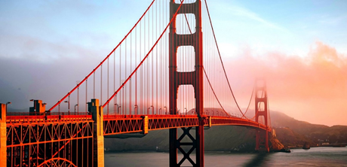
(Make sure there’s Number 1 next to the buttons if you just want to listen to it once. Otherwise you can click and get 2, 3 or 4 depending on the times you want to listen to every sentence)

http://www.manythings.org/listen/goldengate.html

QUESTIONS | COMPLETE ANSWERS, please!  (Subject + Verb + Complements)
1.How many people visit it each year?
2.Why was it coloured “International Orange”? | 2 reasons:  1.  2.
3.What does the Golden Gate Bridge link?
4.If it opened in 1937, how old is it?
(let’s do a bit of Math)
5.What were the strongest safety protections? | 1.  2.  3.
6.How many lives were saved? How many people died? | - Lives saved:  - People who died:

Video: What Do You Know About the Golden Gate Bridge? 3:02

Let’s have a look at it by clicking on this link.
https://www.youtube.com/watch?v=6HygbD44_j4

And that’s all for this week! I hope you had fun and learnt lots of interesting things about one of the world’s most beautiful bridges.
All the best,
TeacherCarmen

