WEEK APRIL 27th to MAY 1st
ENGLISH (ACTIVITAT DE RETORN)

Dear 6th Graders,
Here teacherCarmen! How are you? How’s your English practice? I hope you are doing well and watching films, series, cartoons or listening to my podcasts! There are already 20 created for you!
This week I’m going to ask you to practice Past Simple a little bit! Are you ready for that? I hope so because I’ve got really cool activities prepared for you. Look!
Click on these links and get to this awesome website where you have LIVE WORKSHEETS, which means that you can answer them on the computer. Isn’t that cool?
When you are done, click on FINNISH and check your answers! If you had some mistakes, do it again! Practice makes Perfect!

1. Regular and Irregular Verbs Revision (Use the Irregular Verbs mini-book if necessary or our friend Mr.Google)
https://www.liveworksheets.com/worksheets/en/English_as_a_Second_Language_(ESL)/Past_tenses/Past_tense_(regular_and_irregular_verbs)_ju48014pk
https://www.liveworksheets.com/worksheets/en/English_as_a_Second_Language_(ESL)/Irregular_verbs/Irregular_verbs_kg183ji
https://www.liveworksheets.com/worksheets/en/English_as_a_Second_Language_(ESL)/Past_simple/Past_Simple_Tense_aj1702rz
https://www.liveworksheets.com/worksheets/en/English_as_a_Second_Language_(ESL)/Irregular_verbs/Past_Simple_Tense_-_Worksheet_jc1437it

2. Once you’ve revised the verbs in past now it’s time to write your text in past! Choose one of your favourite trips done in the past and write a letter to your teacher explaining it.
Mention when and where you went, who you went with, how, why you liked it, how the weather/food was or whatever you consider important to say. You can either write it on the computer or do it on a piece of paper with a picture, take a photo and send it to me!
Note: I provide and example so you have an idea.
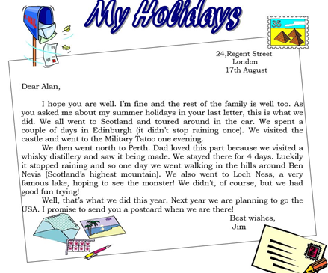
I hope everything is clear and you write excellent letters back to me! We already practised with the Finnish at the beginning of the course, so now with your teacher! Penpals!
Take care and I can’t wait to receive your fabulous adventures around the world when we could still travel…
All the best,
Carmen
P.S. Notice that the whole format of these homework is like a letter! Remember to greet at the beginning and say goodbye at the end! 😊

