Name: ............................................................................................................................ Group: .........................

NUMBERS
(NÚMEROS 0-100)

Surten a l'examen del 3r trimestre: números 1-100.

TELLING THE TIME
(HORES EXACTES)
Les hores no surten a l'examen del tercer trimestre. Només en fem un tastet per estar preparats per 4t. Us hem posat algunes parts dels apunts en castellà, ja que les hores en anglès s'assemblen molt al castellà.

O'CLOCK (EN PUNTO)
 | 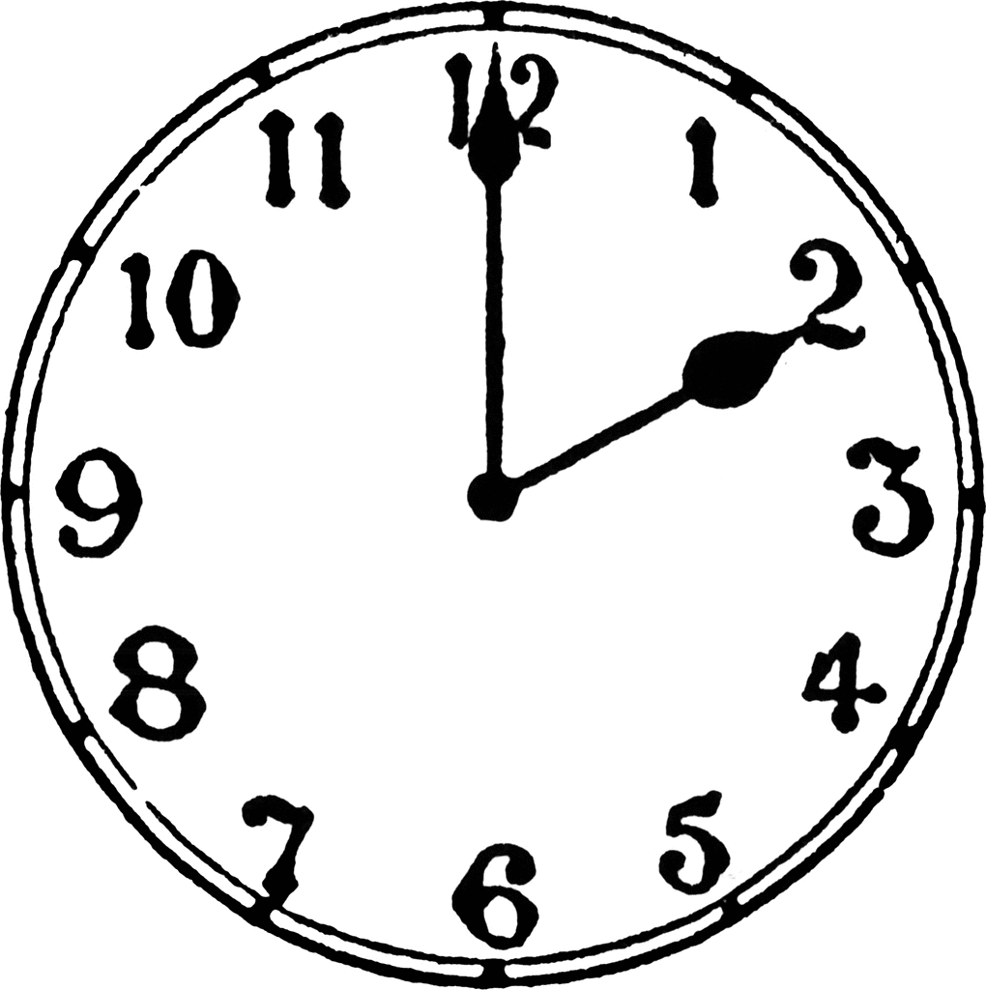 |  |  | 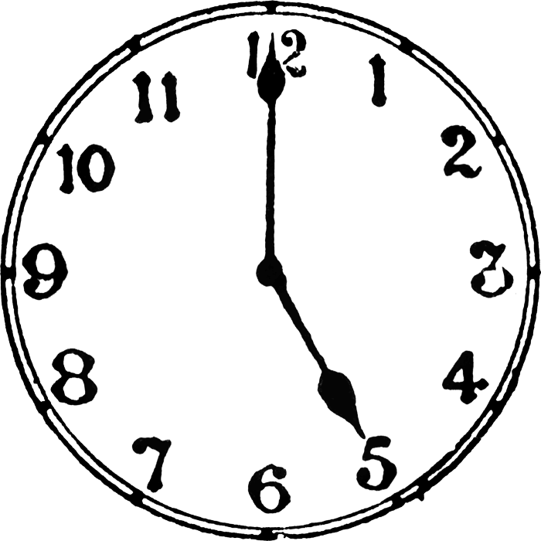 | 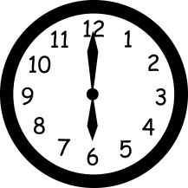
01:00. | 02:00. | 03:00. | 04:00. | 05:00. | 06:00.
ONE  O'CLOCK | TWO  O'CLOCK | THREE  O'CLOCK | FOUR  O'CLOCK | FIVE  O'CLOCK | SIX  O'CLOCK
 |  | 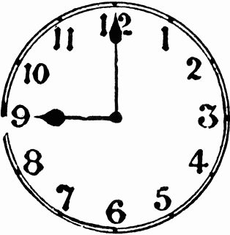 | 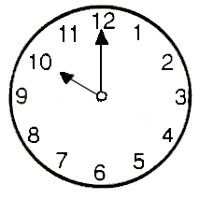 | 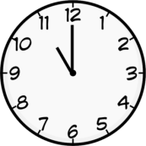 | 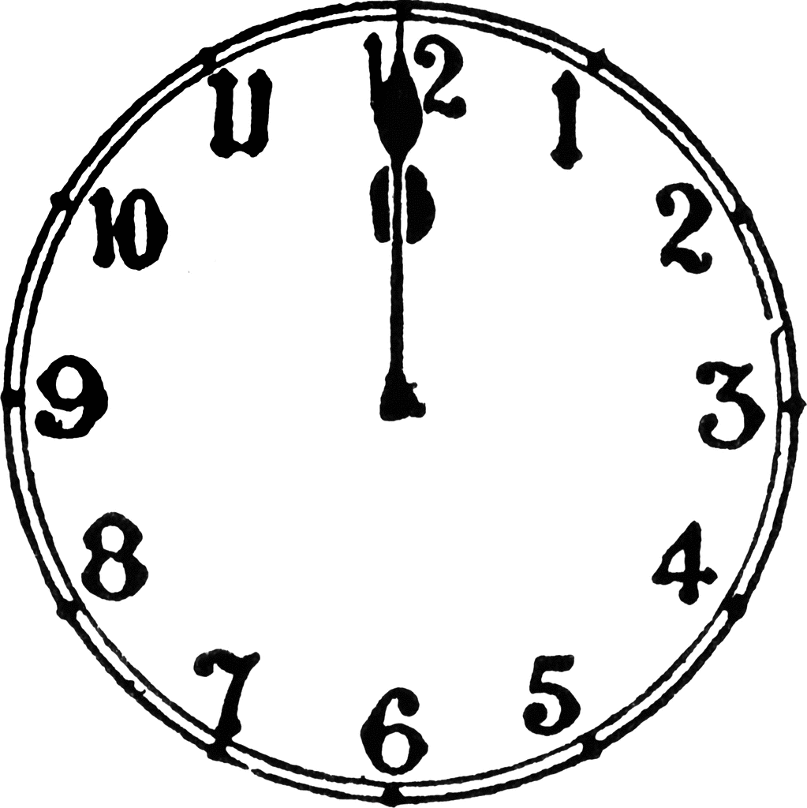
07:00. | 08:00. | 09:00. | 10:00. | 11:00. | 12:00.
SEVEN  O'CLOCK | EIGHT  O'CLOCK | NINE  O'CLOCK | TEN  O'CLOCK | ELEVEN  O'CLOCK | TWELVE  O'CLOCK
HALF PAST (Y MEDIA)
01:30. | 02:30. | 03:30. | 04:30. | 05:30. | 06:30.
HALF PAST  ONE | HALF PAST  TWO | HALF PAST  THREE | HALF PAST  FOUR | HALF PAST  FIVE | HALF PAST  SIX
07:30. | 08:30. | 09:30. | 10:30. | 11:30. | 12:30.
HALF PAST  SEVEN | HALF PAST  EIGHT | HALF PAST  NINE | HALF PAST  TEN | HALF PAST  ELEVEN | HALF PAST  TWELVE
Name ................................................................................................................ Group ......................................

NUMBERS AND CLOCK TRAINING BOOKLET

Aquest és un dossier d'entrenament. Conté un exercici de números i un d'hores per a cada setmana del trimestre (aproximadament).

Portarem un control dels deures en la següent graella: verd si estan fets, vermell si no.

WEEK | 1st | 2nd | 3rd | 4th | 5th

Entendrem que els deures estan mal fets a partir de 3 errors de 5. No podeu fer faltes!

EXAMPLE
 | nine o'clock
09:00. |  |  | 09:30.
50 + 6 | 60 + 6 | 70 + 6 |  | 80 + 6 |  | 90 + 6
56
fifty six

1st WEEK |  | DATA DE CORRECCIÓ:
01:00. |  |  | 02:00.
10 + 2 | 20 + 2 | 30 + 2 |  | 40 + 2 |  | 50 + 2

2nd WEEK |  | DATA DE CORRECCIÓ:
03:00. |  |  | 04:00.
10 + 1 | 20 + 1 | 30 + 1 |  | 40 + 1 |  | 50 + 1

3rd WEEK |  | DATA DE CORRECCIÓ:
07:00. |  |  | 12:00.
10 + 3 | 20 + 3 | 30 + 3 |  | 40 + 3 |  | 50 + 3

4th WEEK |  | DATA DE CORRECCIÓ:
10:00. |  |  | 10:30.
10 + 4 | 20 + 4 | 30 + 4 |  | 40 + 4 |  | 50 + 4

5th WEEK |  | DATA DE CORRECCIÓ:
05:00. |  |  | 05:30.
10 + 5 | 20 + 5 | 30 + 5 |  | 40 + 5 |  | 50 + 5

CORRECTION

1st WEEK |  | DATA DE CORRECCIÓ:
 | one o'clock |  |  |  | TWO O'CLOCK
01:00. |  |  | 02:00.
10 + 2 | 20 + 2 | 30 + 2 |  | 40 + 2 |  | 50 + 2
12 | 22 | 32 |  | 42 |  | 52
twelve | TWENTY TWO | THIRTY TWO |  | FORTY TWO |  | FIFTY TWO

2nd WEEK |  | DATA DE CORRECCIÓ:
 | THREE O'CLOCK |  |  |  | FOUR O'CLOCK
03:00. |  |  | 04:00.
10 + 1 | 20 + 1 | 30 + 1 |  | 40 + 1 |  | 50 + 1
11 | 21 | 31 |  | 41 |  | 51
ELEVEN | TWENTY ONE | THIRTY ONE |  | FORTY ONE |  | FIFTY ONE

3rd WEEK |  | DATA DE CORRECCIÓ:
 | SEVEN O'CLOCK |  |  |  | TWELVE O'CLOCK
07:00. |  |  | 12:00.
10 + 3 | 20 + 3 | 30 + 3 |  | 40 + 3 |  | 50 + 3
13 | 23 | 33 |  | 43 |  | 53
THIRTEEN | TWENTY THREE | THIRTY THREE |  | FORTY THREE |  | FIFTY THREE

4th WEEK |  | DATA DE CORRECCIÓ:
 | TEN O'CLOCK |  |  |  | HALF PAST TEN
10:00. |  |  | 10:30.
10 + 4 | 20 + 4 | 30 + 4 |  | 40 + 4 |  | 50 + 4
14 | 24 | 34 |  | 44 |  | 54
FORTEEN | TWENTY FOUR | THIRTY FOUR |  | FORTY FOUR |  | FIFTY FOUR

5th WEEK |  | DATA DE CORRECCIÓ:
 | FIVE O'CLOCK |  |  |  | HALF PAST FIVE
05:00. |  |  | 05:30.
10 + 5 | 20 + 5 | 30 + 5 |  | 40 + 5 |  | 50 + 5
15 | 25 | 35 |  | 45 |  | 55
FIFTEEN | TWENTY FIVE | THIRTY FIVE |  | FORTY FIVE |  | FIFTY FIVE
6th WEEK |  | DATA DE CORRECCIÓ:
 | HALF PAST NINE |  |  |  | NINE O'CLOCK
09:30. |  |  | 09:00.
50 + 6 | 60 + 6 | 70 + 6 |  | 80 + 6 |  | 90 + 6
56 | 66 | 76 |  | 86 |  | 96
FIFTY SIX | SIXTY SIX | SEVENTY SIX |  | EIGHTY SIX |  | NINETY SIX

7th WEEK |  | DATA DE CORRECCIÓ:
 | HALF PAST TWO |  |  |  | HALF PAST SIX
02:30. |  |  | 06:30.
50 + 7 | 60 + 7 | 70 + 7 |  | 80 + 7 |  | 90 + 7
57 | 67 | 77 |  | 87 |  | 97
FIFTY SEVEN | SIXTY SEVEN | SEVENTY SEVEN |  | EIGHTY SEVEN |  | NINETY SEVEN

8th WEEK |  | DATA DE CORRECCIÓ:
 | HALF PAST FOUR |  |  |  | A QUARTER PAST FOUR
04:30. |  |  | 04:15.
50 + 8 | 60 + 8 | 70 + 8 |  | 80 + 8 |  | 90 + 8
58 | 68 | 78 |  | 88 |  | 98
FIFTY EIGHT | SIXTY EIGHT | SEVENTY EIGHT |  | EIGHTY EIGHT |  | NINETY EIGHT

9th WEEK |  | DATA DE CORRECCIÓ:
 | HALF PAST ONE |  |  |  | A QUARTER PAST ONE
01:30. |  |  | 01:15.
50 + 9 | 60 + 9 | 70 + 9 |  | 80 + 9 |  | 90 + 9
59 | 69 | 79 |  | 89 |  | 99
FIFTY NINE | SIXTY NINE | SEVENTY NINE |  | EIGHTY NINE |  | NINETY NINE

10th WEEK |  | DATA DE CORRECCIÓ:
 | HALF PAST ELEVEN |  |  |  | ELEVEN O'CLOCK
11:30. |  |  | 11:00.
20 + 9 | 80 + 4 | 90 + 2 |  | 70 + 5 |  | 30 + 7
29 | 84 | 92 |  | 75 |  | 37
TWENTY NINE | EIGHTY FOUR | NINETY TWO |  | SEVENTY FIVE |  | THIRTY SEVEN

