Look, find and circle. Then look and find other English words you know.
r | i | c | e | a | h | e | l | l | o | b | b | c | w | d
e | p | g | a | r | d | e | n | i | n | g | r | h | a | f
w | i | n | d | s | u | r | f | i | n | g | e | i | s | o
f | z | c | t | s | c | h | o | o | l | h | a | p | h | o
g | z | a | w | h | f | j | c | a | t | u | d | p | i | t
t | a | n | o | m | o | s | a | l | a | d | r | o | n | b
e | w | o | e | u | u | r | f | i | v | e | o | d | g | a
n | r | e | d | m | r | s | e | b | o | y | l | o | u | l
j | u | i | c | e | g | u | i | t | a | r | l | g | p | l
t | v | n | t | h | o | r | s | e | r | i | d | i | n | g
v | e | g | e | t | a | b | l | e | s | m | a | t | h | s

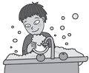
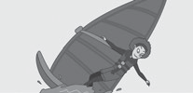
1
10
windsurfing
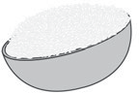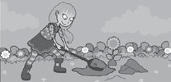
2
9
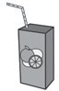
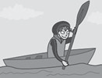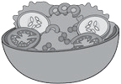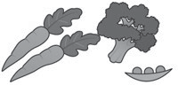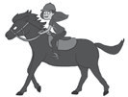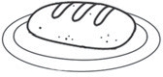
3
8
4
5
6

hello

How do you say the dates?
2
3
4
1

the | 3rd | of | ƒebruary

- Look and complete.
January 8   | February | March
April | May 2   | June 27  
July 30   | August | September
October | November 14   | December

When’s your birthday?

 My birthday is the 14th of November.
1


2
My birthday is the of .
3
4
5

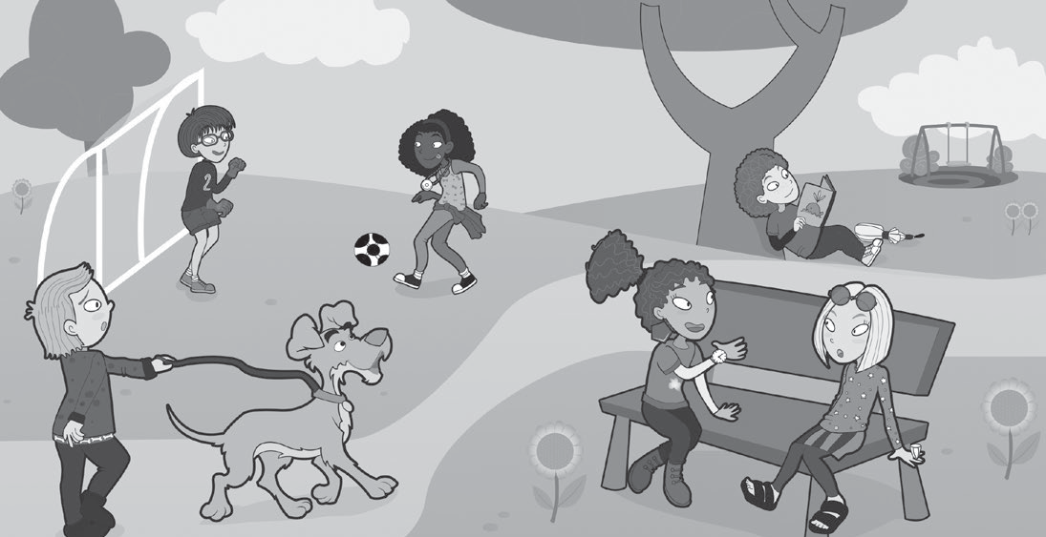Read and write the names.
Jim is short. He’s got glasses.
Julia is tall. She’s got long, curly hair. Lily’s got short, straight hair.
Clare’s got curly, dark hair. Fred’s got short fair hair.
Charlie’s got curly, dark hair.
2
3
1 ¯im
4
5
6

- Look again at the picture in Activity 1. Find these objects and write.
This These
watch sunglasses umbrella belt earrings gloves ring necklace

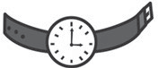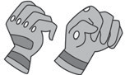†hiš iš ¯ulia’š watch. †hese are
1
2
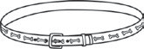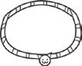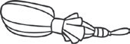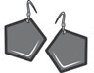
3
4
5
8

- Draw and label your things. Use these are and this is.
6


†hese are my glasseš.

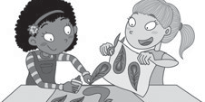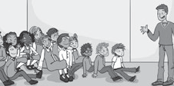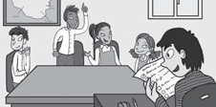Complete the crossword.
2
6
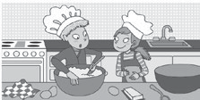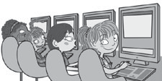
1
1  2 |  | c
 |  | o
3 |  | o |  |  |  |  |  |  |  |  |  |  | 4
 |  | k |  |  |  |  |  |  |  | 5
 |  | e |  |  |  | 6
 |  | 7r
 |  | y
 |  | c
 |  | l
 |  | u |  |  |  | 8
 |  | b

5


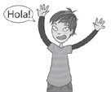
- 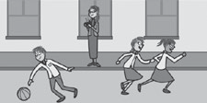Look, write and match.
✔✔✔ always ✔✔ usually ✔ sometimes ✘ never
3
4
8
1 She ✔✔✔ alwayš 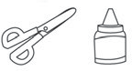 . d
2 They ✘ 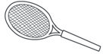 .
3 We ✔✔ 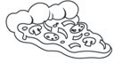 .
4 He ✔ 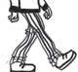 .
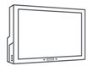
5 They ✔✔ 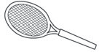 .
6 He ✔✔✔ .

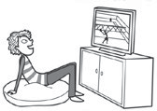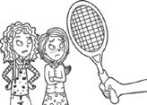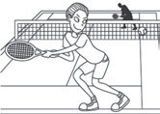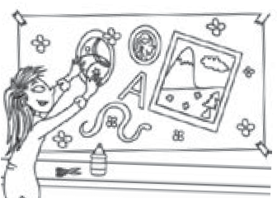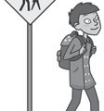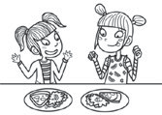
a
b
c
d
e
f

- Complete and write sentences that are true for you.
  - I walk to school. 4
  - I go to cookery club. 5
  - I play football at break.

- Look and complete. Then match.
abseiling archery badminton climbing diving gymnastics hockey swimming table tennis trampolining

play | go | do
1 play badminton | 4 | 9
2 | 5 | 10
3 | 6
 | 7
 | 8
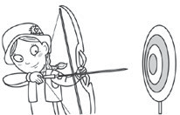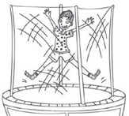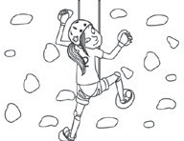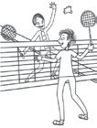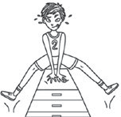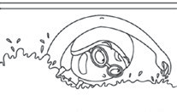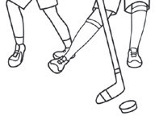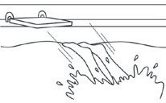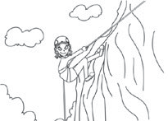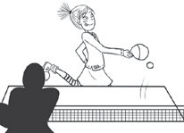
a
b
c
d
1
e
f
g
h
i
j

- Look, read and tick ✔ the correct sentence.
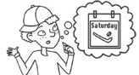
  - He’s playing hockey.
He plays hockey on Saturdays.
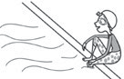
  - She goes swimming on Tuesdays and Thursdays.
She’s going swimming.
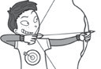
  - He does archery on Fridays.
He’s doing archery.
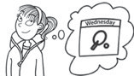
  - She’s playing table tennis.
She plays table tennis on Wednesdays.

- Look and write.
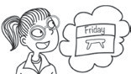
1

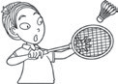
2

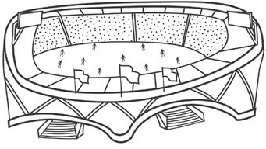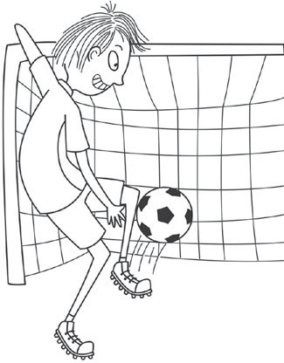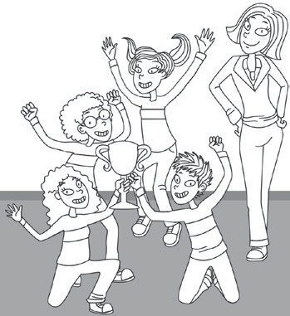
2 m
1 s
4 g
3 p
5 t
6 w

Look, circle and match.
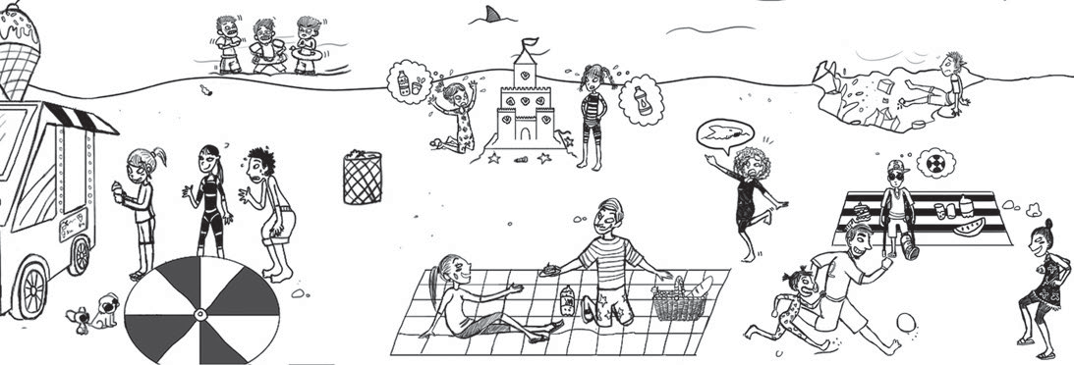
1
2
3
4

  - Why are they tired / cold?
  - Why are they hungry / thirsty?
  - Why is he happy / sad?
  - Why is she happy / scared?
a Because she can see a dangerous animal. b Because they’re hot.
c Because they’re in the sea. d Because he’s got a cut.

- 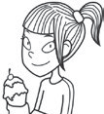Look and find these children. Order the words to make sentences.
1

Why is she happy? she / an ice cream / Because / ’s got

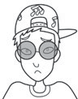Why is he sad? can’t / he / football / Because / play
2

4
1 epehtnla
2
clema
3
cdileocor


rabe

5


gafferi

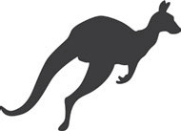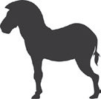 elephant
6
kooragna
7
nlio
8
meykno
9
snkae
10
brzea

- Read and tick ✔ True or False.
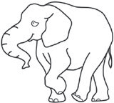
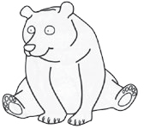
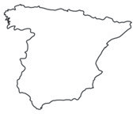
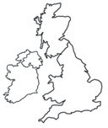
1 2

An elephant is heavier than a bear. True False
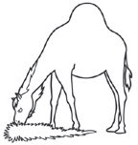
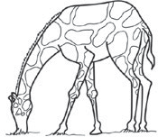
3

A camel is taller than a giraffe. True False
Spain is hotter than the UK. True False
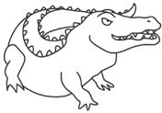
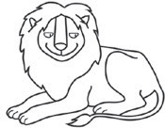
4

A crocodile is faster than a lion. True False

- Look and write sentences that are true for you.
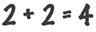



1 2
Maths English
Me
My teacher

is better than is older than

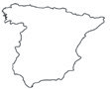
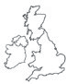
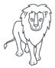
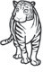
3 4
The UK Spain
lion a tiger

- Look and complete.
best worst strongest cleverest fastest tallest
  - Rabbit 1 is the tallest rabbit.
  - 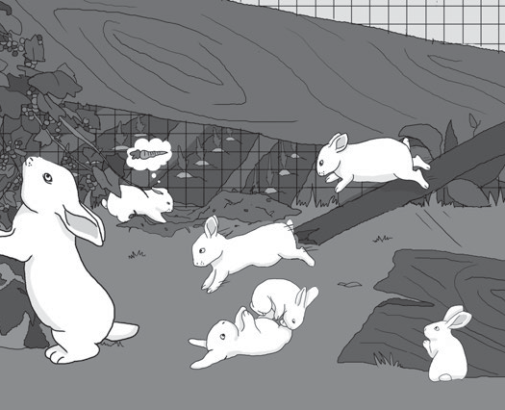Rabbit 2 is the rabbit.
1
3
2
4
5
6
  - Rabbit 3 is the at jumping.
  - Rabbit 4 is the rabbit.
  - Rabbit 5 is the rabbit.
  - Rabbit 6 is the at climbing.

- Look, read and answer.
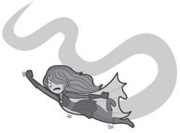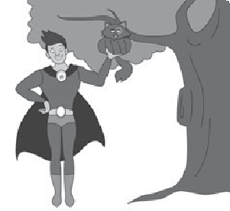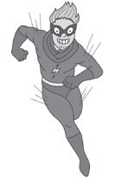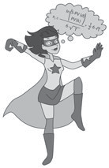
Minnie
12
strong flying
kung fu
Max
10
strong
flying kung fu
Mowgli
11
strong
flying kung fu
Mel
9
strong
flying kung fu

1 Who’s the oldest? | µinnie iš the oldest.
2 Who’s the strongest?
3 Who’s the best at kung fu?
4 Who’s the tallest?
5 Who’s the worst at flying?
6 Who’s the fastest?

- Complete the table.

 | clever | big | tall | fast | good
comparative | cleverer
superlative | cleverest

- 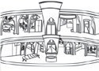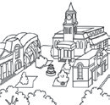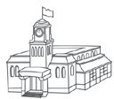Complete the puzzle and find the missing building.
9
8
k
7
6
m
5
4
3
2
1
4
5
6
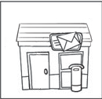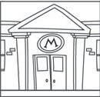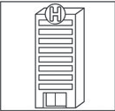
1
2
3

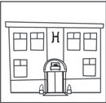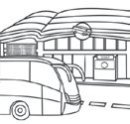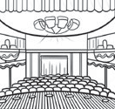The missing building is the .
8
9

- Look and write the year.
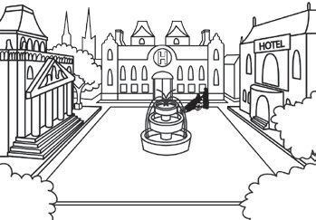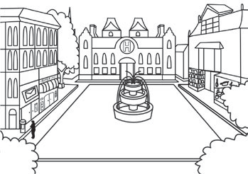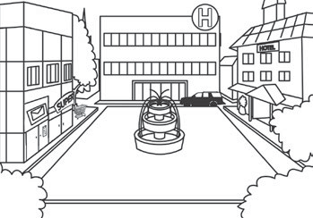
1816
1916
2016

  - There was a hospital.
  - There weren’t any shops.
  - There wasn’t a post office.
  - There was a supermarket.
  - There was a museum.
  - There wasn’t a hotel.

- Look at the pictures again and write sentences.
1 In 1816, there waš . 2 In 1916, .
3 In 2016, .

- 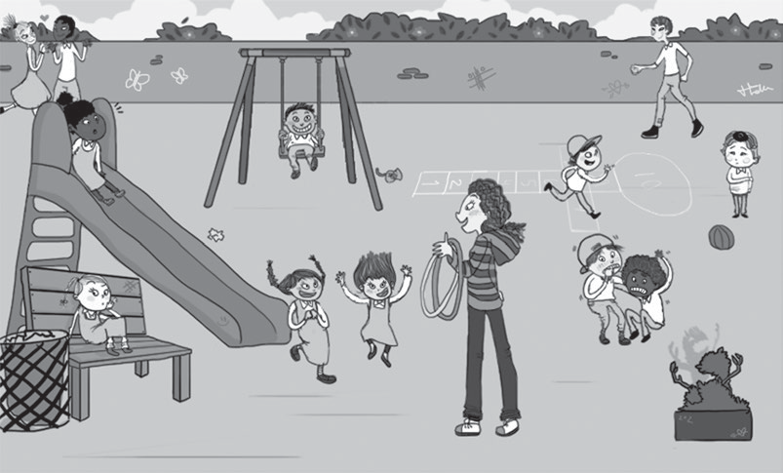Read and match.
  - He was happy.
  - They were excited.
  - She was bored.
  - They were scared.
  - He was friendly.
  - You were worried.

- Look and write.
bored excited friendly happy scared worried

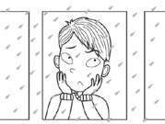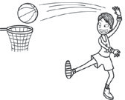Yesterday he waš bored . Today he’š happy .
1
Yesterday

Today

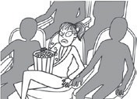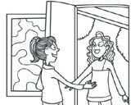Yesterday she . Today .
2
Yesterday

Today

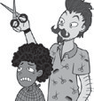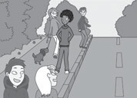Yesterday . Today .
3
Yesterday

Today

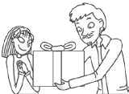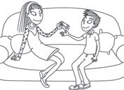Yesterday . Today .
4
Yesterday

Today

- Write and draw about you.
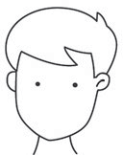
¥esterday †oday
1
2

- Look, write and match.
computer programmer firefighter journalist engineer gardener cook artist musician scientist police officer
play paint cook talk to play plant design discover climb walk


  - He’s a
musician .

  - She’s a
.


  - She’s a
.


  - He’s a
.

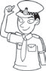
  - He’s a
.

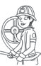
  - She’s a
.

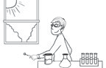
  - He’s a
.

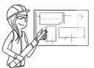
  - She’s an
.

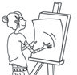
  - She’s an
.


  - He’s a
.

- Write sentences that are true for you.
- Yesterday I TV.
- Yesterday I to music.
- Yesterday I football.
- Yesterday I a pizza.
Yesterday…

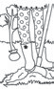

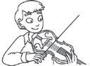
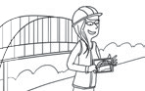
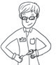


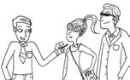

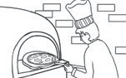
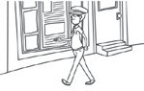
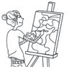

- She a tree.

- 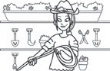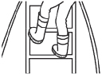She a ladder.

- He played
the violin.

- She a bridge.

- He a new medicine.

- She a computer game.

- He a celebrity.

- He a pizza.

- He for 10 km.

- She a picture.
listened – didn’t listen cooked – didn’t cook watched – didn’t watch played – didn’t play

- 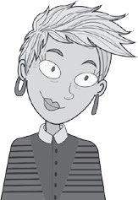Read and complete.
university professor husband daughter

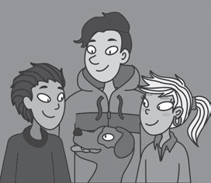

- Look and complete in the past tense.
become make win go have meet
This is Mrs Brown. She’s a
- professor at a
- 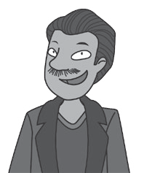 in London.

This is her (3) , Mr Brown. He’s an engineer.

They’ve got 2 sons and 1
- , and they’ve got a dog called Denzil.

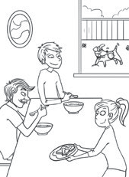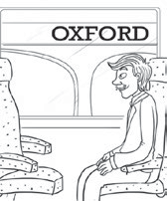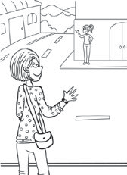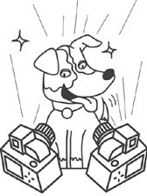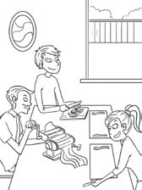
1
2
3
4
5
6

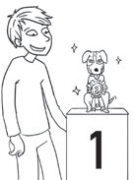
  - The family breakfast together.
  - Mr Brown to Oxford.
  - Mrs Brown a friend.
  - Denzil 1st prize at the dog show.
  - He famous.
  - The family pasta for dinner.

3 Write sentences that are true for you.
Yesterday …
- I went to .
- I met .

- I had for lunch.
- I made .

- Look and reorder the letters.
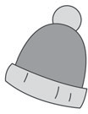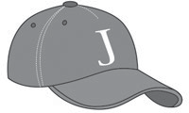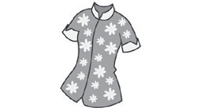2 t o
4
o
l
1
w
o
g
s
a
s
l
3
s
l
i
k
4
t o
n c
hat shirt
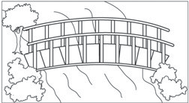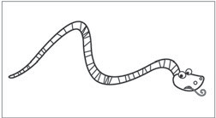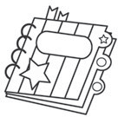baseball cap marble
e
n
d
o
o
5 w
b
b
r
e
6
u
r
l a
t
m
e
a
p p
e
r
8

bridge
snake
badge
book

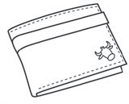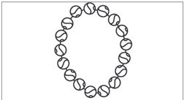
t h

a
r
e
e
l
9
t
a
l
s
i
10
p
c

wallet

- Order and write.
necklace

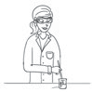
  - A / has to / plastic glasses / scientist / wear

å scientist
  - chef / paper hat / A / wear / has to / a

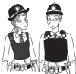
  - Police officers / wear / have to / belts

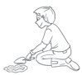
  - A / doesn’t / wear / gardener / have to / a jumper

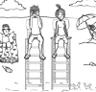
  - Lifeguards / wear / don’t / have to / socks

- Write sentences that are true for you.
have to don’t have to
- I wear a hat and sunglasses on a hot day.
- I wear a coat in winter.
- I wear a uniform to school.

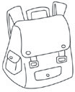
- 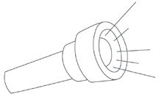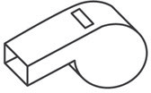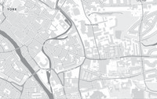Complete the crossword.
1
2
4
5

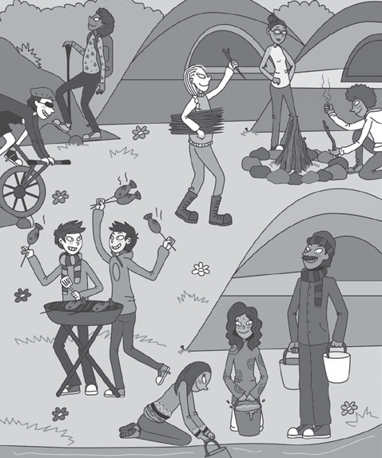
- 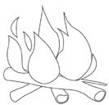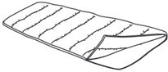Look, find and answer.
6
5
4
3
2
1
3
6

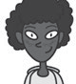
1

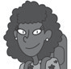
2


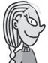
4
5

Did he make a fire?

Did she cook fish?

Did they get water?

Did he make a fire?

Did she get wood?

Did they go mountain biking?

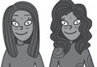
3

- 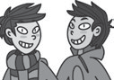Answer the questions for you.
6
  - Did you go swimming yesterday?
  - Did you have an art lesson yesterday?
  - Did you watch TV yesterday?
  - Did you eat pizza yesterday?
  - Did you play a computer game yesterday?

1 Complete and match.
1 climb a
omanintu

mountain g

6 cook on the
preifamc

- go
ksuertfngii
- take
oosthp
- go
ihngisf
- go to the
- play
echab
eyalblllov
- swim in the
alek

5 visit a 10 go
selatc
agnivc
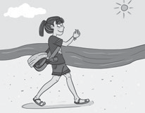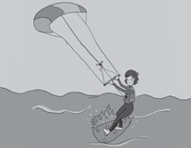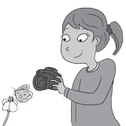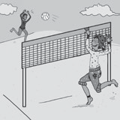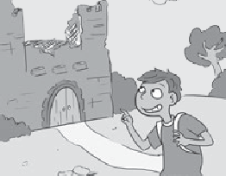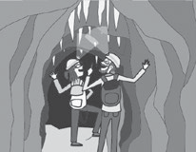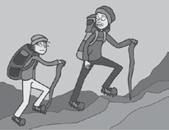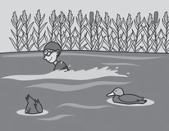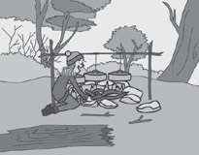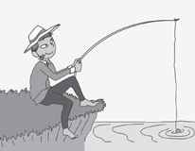
a
b
c
d
e
f
g
h
i
j

- 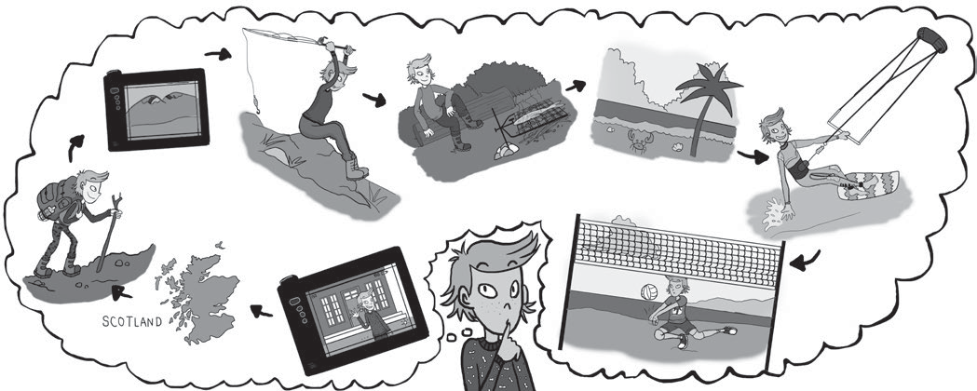Look and write.

At the weekend, I’m going to go to (1) . I’m going to
(2) a mountain and (3) photos.
I’m (4) fishing and then (5) cook the fish on the (6) .
On Sunday (7) to the beach. I’m going to (8) kitesurfing and (9) volleyball. What a busy weekend!

- Look and write about Zoe’s weekend.
åt the weekend, Ωoe iš
✔ visit a castle
✔ swim in the lake
- climb a mountain
- go caving

- Find, circle and write.
s | e | c | u | s | t | o | m | e | r | w | s
i | b | h | s | h | e | a | l | e | i | n | m
o | g | e | w | b | a | r | b | e | c | u | e
p | s | f | o | p | i | u | n | r | k | r | n
w | a | i | t | r | e | s | s | w | s | s | u
f | l | w | a | r | w | a | i | t | e | r | w
l | m | a | i | n | c | o | u | r | s | e | s


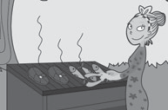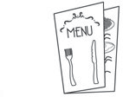
1
2
3
customer
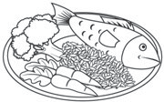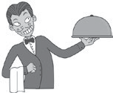
4
5
6

Look and write.
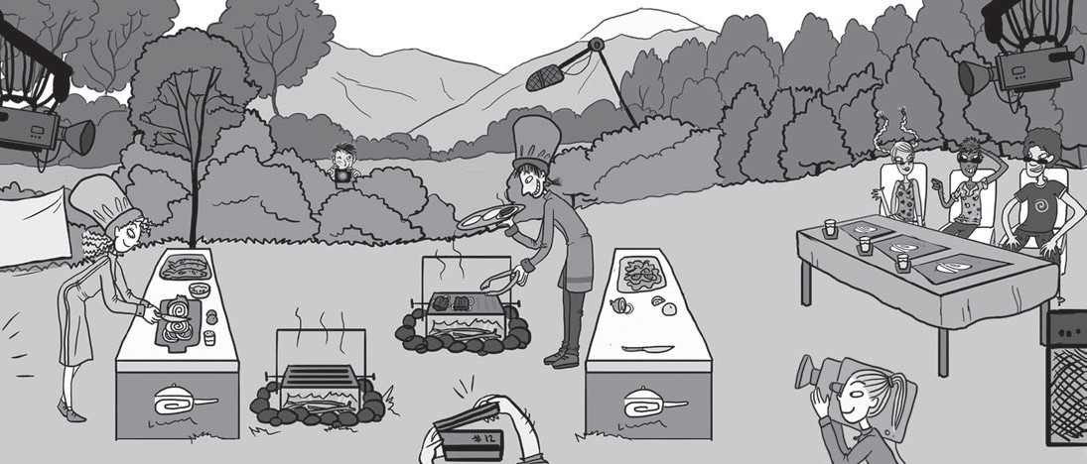
1
2
4
5
3
6

1 Is it going to rain? | ²o, it isn’t.
2 Is he going to take photos?
3 Is she going to cook the main course?
4 Is he going to cook some fish?
5 Are they going to take photos?
6 Is she going to cook dinner?

- Choose ✔ activities and write what you are going to do on holiday.

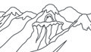 | 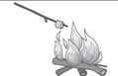 | 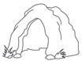 | 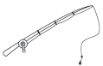 | 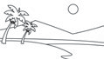 | 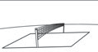 | 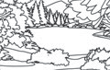 |  | 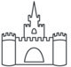
ý’m

- Read and look. Complete the sentence.
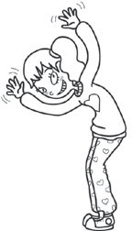
I play football on Saturdays. I play hockey on Sundays. I play table tennis
Mary’s timetable
Saturday
Sunday | 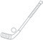
Monday | 

twice a week. I never do archery. I on Mondays.

- Complete. Use the present simple or the present continuous.
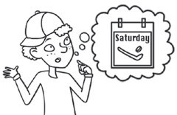
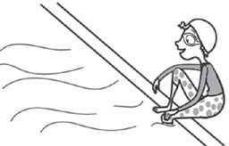
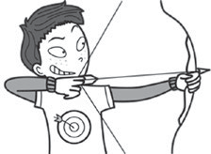
1
2
3
He playš hockey She He
on Saturdays. now. today.
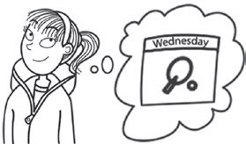
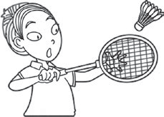
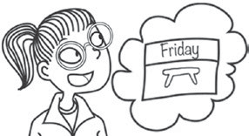
4
5
6

She
She
He

every week. on Fridays. this afternoon.
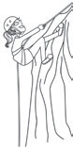
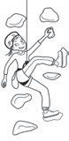
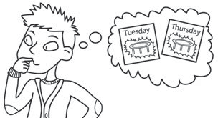
8
9

He
She
She

on Tuesdays and Thursdays. today. at school.

- Write 4 sentences that are true for you. Use the words in the box.
on Mondays at the weekend today now
1 I .
2 I .
3 I .
4 I .

- Complete the crossword.
  - 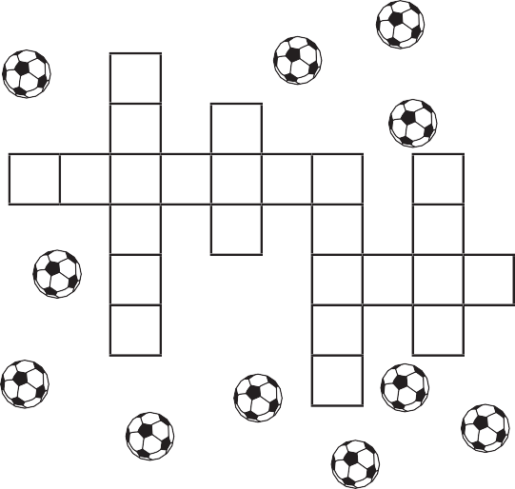Cesc Fabregas is a football p .
1 p

  - My team always wants 2 
to .

  - Wembley is a big football
in London.
  - The football starts at 3 o’clock.
  - Look! He’s scoring a ! It’s 1 – 0.
3 4 5



6



  - My favourite football is Arsenal.

- Read and complete the questions.
3
2
1

- Why are they ? Because they’re in the sea.
- Why ? Because they’re hot.
- ? Because she can see a dangerous animal.

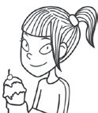
3 Look and find these children. Answer.
1

Why is she happy?

2

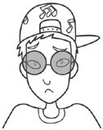
Why is he sad?

- Look and answer.
  - Which is taller?   The is taller than the .
  - Which is heavier?   The .
  - Which is faster?   .
  - Which is longer? 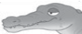  .
  - Which is slower?   .
- Look at the pictures of the lion and the tiger. Guess which animal is longer, heavier and faster.

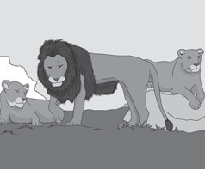
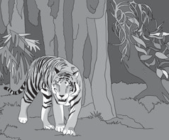
Which is longer? lion tiger

Which is heavier? lion tiger

Which is faster? lion tiger

- Read the text and answer the questions.

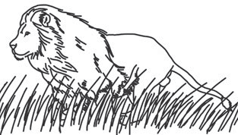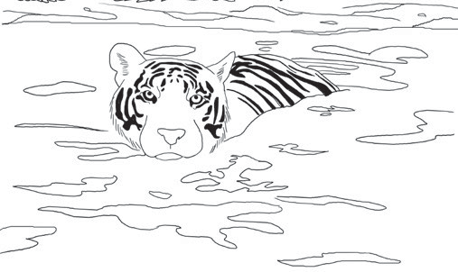Lions and tigers

Lions and tigers are both big cats. Lions live on grassy plains in Africa. Male lions have got a large furry mane around their head. Tigers live in Asia and they’ve got black stripes on their bodies so they can’t be seen in between
the trees.
Which is bigger? Tigers are longer and heavier but lions and tigers are usually about the same height. Tigers are
heavier because they’ve got bigger muscles. An adult male tiger can weigh 420 kg.
Lions are faster than tigers. They can run at nearly 80 km per hour, but tigers only run at 65 km per hour. Tigers are better at swimming than lions. They often swim across rivers and swim to hunt other animals. Lions can swim but they don’t do it very often.

- Which is longer? †he tiger iš longer than the lion.
- Which is heavier?
- Which is faster?
- Which is better at swimming?

- Match the opposites.
fastest

shortest

weakest

best

worst
slowest
strongest
tallest

- Look at the superheroes. Make sentences. Use the pictures to help you.

Minnie
12
strong flying
kung fu
Max
10
strong flying
kung fu
Mowgli
11
strong flying
kung fu
Mel
9
strong flying
kung fu
  - (old) µinnie iš the oldest.
  - (strong)
  - (fast)
  - (good at flying)
  - (tall)
  - (clever)
  - (bad at kung fu)

- Answer the questions about your class.
1 Who is the tallest person in your class? | iš the tallest .
2 Who is the best at Maths?
3 Who is the fastest runner?
4 Who is the best at Art?
5 Who is the kindest?
6 Who is the tidiest?

- Look, read and write the year.
1816
1916
2016

  - There was a hospital.
  - There weren’t any shops.
  - There wasn’t a post office.
  - There was a supermarket.
  - There was a museum.
  - There wasn’t a hotel.

- Look and find the 6 differences. Then write.

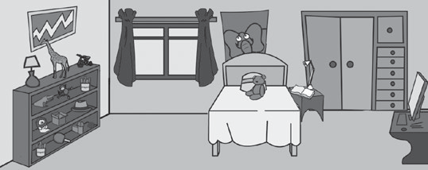
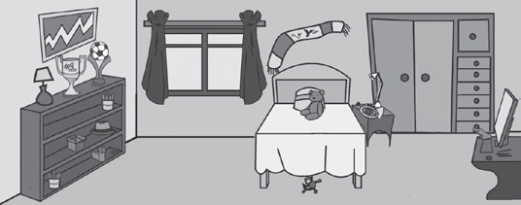
George’s bedroom

Last year Now
cuddly toys a poster of an elephant a table tennis bat a trumpet a scarf football trophies
- Last year, there was a poster of an elephant.
- Last year, there wasn’t .
- Last year, .
- Last year, .
- Last year, .
- Last year, .

3 What was different in your bedroom last year? Write 3 sentences.
Last year,

- Look and complete.
bored friendly excited scared worried happy

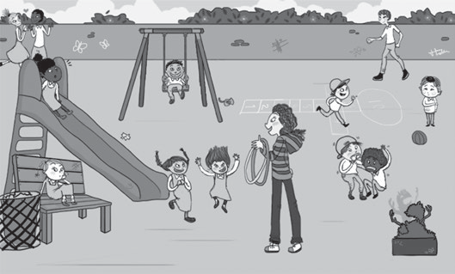1 She was . 2 3
1
2
3
4
6
5
- She was .
- They were . 6

- Look and read. Then complete.
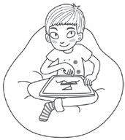
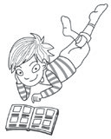
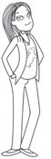
Vicky is 11. She loves animals. She’s got two cats and a rabbit. She wants a horse! At school she loves science and maths.
She’s good at sports, but she can’t swim.
Jim is 9. He loves sports. He goes sailing, windsurfing and canoeing every week. He is good at English, but he doesn’t like maths. He hates snakes and spiders.
Peter is 10. His favourite school subject is maths. His mum is a maths teacher and his dad is also a maths teacher. He likes swimming and football. His favourite film is Spiderman.

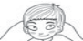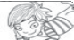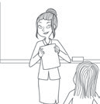On Monday morning there was a maths test
Maths test!

Vicky was . Jim was . Peter was .

On Tuesday the class were at the zoo.
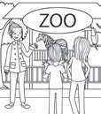
Okay class, let’s go to the reptile house.
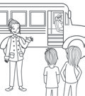On Wednesday it was swimming.
Let’s go to the swimming pool!

Vicky was . Jim was . Peter was .

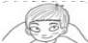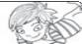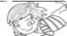Vicky was . Jim was . Peter was .

- Label the pictures. Then find the odd one out and complete the sentence.
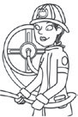
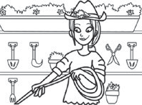
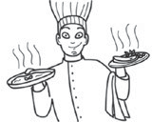
  - The is the odd
one out.

  - The is the
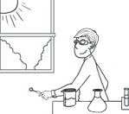
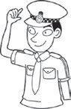
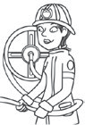
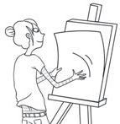
odd one out.

  - The is the odd
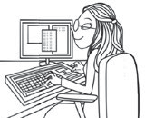

one out.

- Look and complete.
a bridge a computer game a new medicine a ladder a picture the violin for 10 km
a pizza a tree a celebrity
plant design cook talk to play paint play discover climb walk

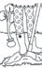The gardener
1

planted a tree .
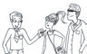The
2
.
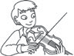The
3
.
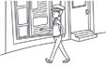The
4
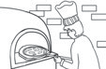 .
5
The
.
The
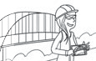 .
6
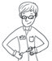The
.
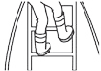The
8
.
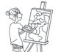The
9
 .
10
The
.

- Write sentences that are true for you.
- (listen to music) yesterday.
- (watch TV) yesterday.
- (play a computer game) yesterday.
- yesterday.

- Complete the mind maps. Can you add any more words?
a friend breakfast a cake to the beach a coffee a toothache a snowman a picnic a prize a doctor to London

a snowman

make
win

meet

have
go

become

- Look and write sentences in the past tense.
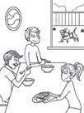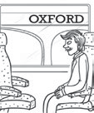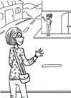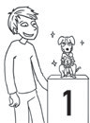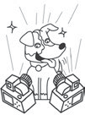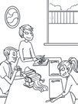
pasta famous a prize at a dog show breakfast a friend to Oxford
a
b
c
d
e
f

  - The family had breakfast .
  - Mr Brown .
  - Mrs Brown .
  - The dog . 5 He .
6 The family .

- Write sentences that are true for you.
make go have meet win become
Yesterday …
1 I .
2
3
4

- Look and complete.
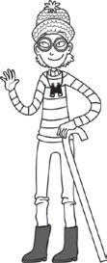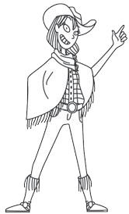
plastic rubber wool metal wooden silk leather cotton leather
I’m wearing a
(1) wool hat
and (2) glasses. I’m wearing
(3) boots. I’ve got (4) binoculars and a
(5) stick.
I’m wearing a
(6) belt and a (7) shirt and a
- scarf.
I’m wearing
- boots.

- Look and write.
have to / don’t have to has to / doesn’t have to
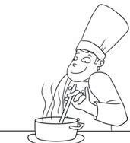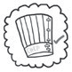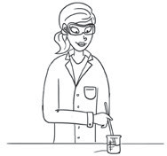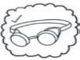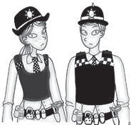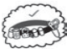™e haš to wear a
1
2
4

paper hat.

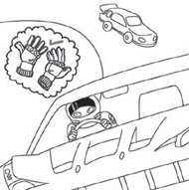
3

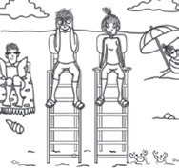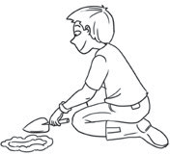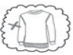
5
6

- Write sentences that are true for you.
have to / don’t have to
hat coat sunglasses school uniform swimsuit
1 I have to wear a hat and sunglasseš in summer . 2 I . 3 I .

- Complete the crossword.

  - It’s made of plastic and glass. You use it to see in the dark.
6
5
4
3
2
1
  - It’s made of strong cotton. You wear it when you go hiking.
  - You make this with wood. You can use it to cook food.
  - It’s made of metal. It makes a loud noise.
  - It’s made of paper. You use it to find out where you are going.
  - It’s made of wool. It keeps you warm at night.

- Look, find and write the questions.
cook fish go mountain biking get wood get water make a fire go hiking

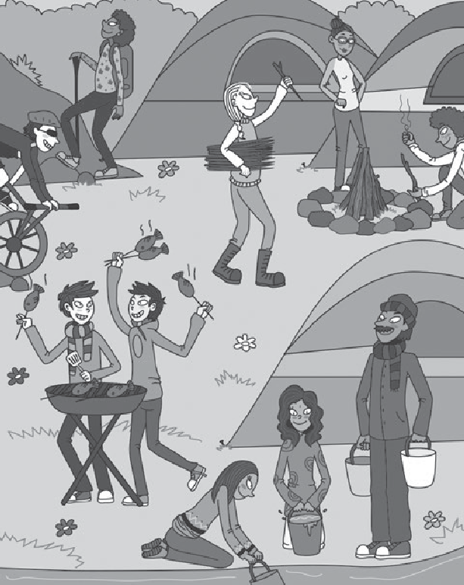
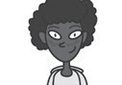Ðid he make a fire?
1
1
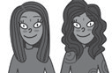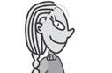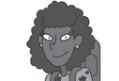Yes, he did.
3
5
2
4
6
3
5
2
4
6

Yes, she did.

Yes, they did.

No, he didn’t.

No, she didn’t.

No, they didn’t.

- Answer the questions for you.
- Did you go swimming yesterday?
- Did you have a maths lesson last week?
- Did you watch TV last weekend?
- Did you climb a mountain last year?
- Did you play a computer game this morning?

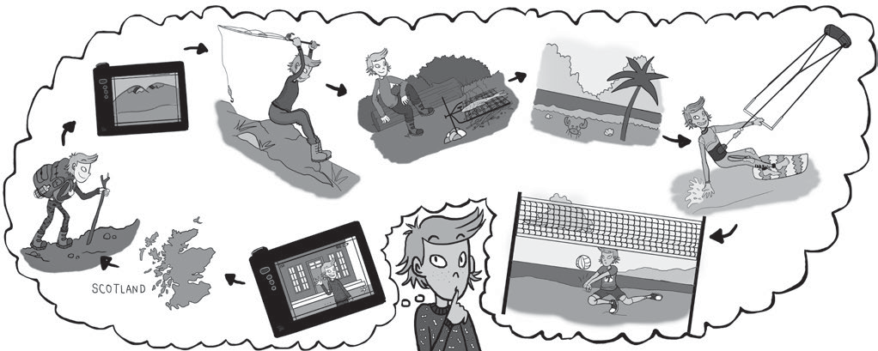
At the weekend, I’m going to go to (1) . I’m going to
(2) a mountain and (3) photos.
I’m (4) fishing and then (5) cook the fish on the (6) .
On Sunday (7) to the beach. I’m going to (8) kitesurfing and (9) volleyball. What a busy weekend!

Write about their holidays.
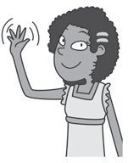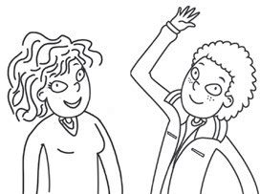
Jane
Lara and Fred
 | visit  a castle | go caving | swim  in the lake | take photos
Jane | ✔ | ✘ | ✔ | ✘
Lara and Fred | ✘ | ✔ | ✔ | ✘

¯ane iš going to ¼ara and ƒred aren’t

,
but she isn’t going to

. .
- Answer the questions about your next holiday.
  - Where are you going to go?
  - What are you going to eat?
  - What are you going to do?

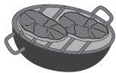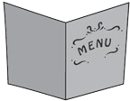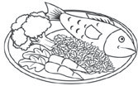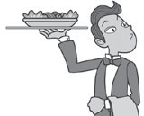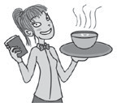
1
2
3
4
5
6

Look and write short answers and sentences.
1
2
4
5
3
6

1 Is it going to rain?  ²o, it isn’t. ýt’š sunny. | 4 | Is he going to cook dinner?
2 Is he going to cook dinner? | 5 | Are they going to take photos?
3 Is she going to cook the main course? | 6 | Is she going to cook the main course?

- Choose ✔ activities and write what you are going to do on holiday.

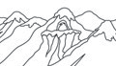 |  |  | 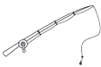
On holiday, I’m

Teaching notes Reinforcement and Extension worksheets

Starter Reinforcement 1
1 Look, find and circle. Then look and find other English words you know.
Pupils look at the pictures, find the words in the wordsearch and circle them. They then write the word under the picture. Pupils then look and see if they can find any other English words in the wordsearch.

Answers
1 windsurfing 2 rice 3 canoeing 4 juice
5 vegetables 6 horse riding 7 bread roll
8 salad 9 gardening 10 washing up
Other words hidden in the wordsearch include: hello, café,
Mixed-ability teaching notes

3 Draw and label your things. Use these are and this is. Pupils draw things that they have got, then write a sentence about each of them using this is and these are.

Answers
Pupils’ own answers.

Starter Reinforcement 3

1 Complete the crossword.
Pupils look at the picture clues and complete the crossword.

Answers

pizza, guitar, mum, hippo, red, school, football, five, maths, cat, ten, TV, boy, two, dog, four

2 How do you say the dates?
Pupils look at the dates and complete the way ordinal numbers are spoken, following the example provided.

Answers
1 the 3rd of February 2 the 11th of April
3 the 22nd of August 4 the 16th of June

3 Look and complete.
Pupils look at the picture of the child, and find them on the calendar. They then complete the speech bubble for the child.
1 cookery club 2 craft club 3 geography 4 Spanish
5 ICT 6 assembly 7 registration 8 break

2 Look, write and match.
Pupils complete the sentences using the key and the picture prompts. They then match the sentences to pictures (a–f).

Answers
1 She always goes to craft club. d 2 They never play tennis. b 3 We usually eat pizza. f 4 He sometimes walks to school. e 5 They usually play tennis. c
6 He always watches TV. a

3 Complete and write sentences that are true for you.

Answers
Answers

- My birthday is the 14th of November.
- My birthday is the 2nd of May. 3 My birthday is the 27th of June. 4 My birthday is the 30th of July.
5 My birthday is the 8th of January.

Starter Reinforcement 2

1 Read and write the names.
Pupils look at the picture and read the sentences.
They then write the names of the children on the labels on the picture.

Answers
- Jim 2 Clare 3 Charlie 4 Fred 5 Julia 6 Lily

Look again at the picture in Activity 1. Find these objects and write.
Pupils look at the small pictures and then try and find the same objects in the large picture in Activity 1. They then write whose object it is.

Answers
1 This is Julia’s watch. 2 These are Jim’s gloves.
3 This is Fred’s belt. 4 This is Clare’s necklace.
5 This is Lily’s ring. 6 These are Lily’s sunglasses.
7 This is Charlie’s umbrella. 8 These are Julia’s earrings.
Pupils’ own answers.

Unit 1 Reinforcement Lesson 2

1 Look and complete. Then match.
Pupils look at the words in the word pool and write them in the correct place in the table. They then match each verb to a picture.

Answers
[NB order is not important]
1 play badminton, d 2 play hockey, g 3 play table tennis, j 4 go abseiling, i 5 go climbing, c 6 go diving, h 7 go swimming, f 8 go trampolining, b
9 do archery, a 10 do gymnastics, e

2 Look, read and tick ✔ the correct sentence.
Pupils look at the picture and read both sentences. They decide which sentence applies to the picture and tick this sentence.

Answers
- He plays hockey on Saturdays.
- She’s going swimming. 3 He’s doing archery.
4 She plays table tennis on Wednesdays.

3 Look and write.
Pupils look at the pictures and write sentences.

Answers
1 She does gymnastics on Fridays. 2 He’s playing badminton.

Unit 1 Reinforcement Lesson 6

1 Look and write.
Pupils look at the pictures and complete the word labels with the correct spelling.

Answers
1 stadium 2 match 3 player 4 goal 5 team
6 win

2 Look, circle and match.
Pupils look at the picture and find the numbered children. They then circle the word that describes the child’s emotion. They then match the completed question to
an answer (a–d).

Answers
1 cold, c 2 thirsty, b 3 sad, d 4 scared, a

3 Look and find these children. Order the words to make sentences.
Pupils identify the children, then reorder the words to answer the questions.

Answers
- Because she’s got an ice cream.
- Because he can’t play football.

Unit 2 Reinforcement Lesson 2

1 Look and write.
Pupils look at each picture, solve the anagram, and write the word.

Answers
1 elephant 2 camel 3 crocodile 4 bear 5 giraffe
6 kangaroo 7 lion 8 monkey 9 snake 10 zebra
2 Read and tick ✔ True or False.
Pupils read the statement and look at the pictures. They decide if the statement is true or false and tick the relevant box.

Answers
1 True 2 True 3 False 4 False

3 Look and write sentences that are true for you.
Pupils look at the pictures and write a sentence using
a comparative that is true for them, using the word pool for reference.

2 Look, read and answer.
Pupils look at the four trump cards. They then read the questions and write answers based on the information on the trump cards.

Answers
1 Minnie is the oldest. 2 Max is the strongest.
3 Mel is the best at kung fu. 4 Max is the tallest.
5 Minnie is the worst at flying. 6 Mowgli is the fastest.

3 Complete the table.
Pupils complete the table with comparative and superlative forms.

Answers
clever – cleverer – cleverest big – bigger – biggest
tall – taller – tallest fast – faster - fastest good – better - best

Unit 3 Reinforcement Lesson 2
1 Complete the puzzle and find the missing building. Pupils look at each picture and write the word in the crossword. They then look at the column shaded grey to spell out the name of the missing building.

Answers
1 post office 2 museum 3 hospital 4 shopping
centre 5 square 6 town hall 7 theatre 8 hotel
9 bus station
The missing building is the supermarket.

Look and write the year.
Pupils read each sentence and look at the three pictures. They decide which picture(s) the sentence applies to and write down the relevant year(s).

Answers
1 1816, 1916, 2016 2 1816 3 1816 4 2016
5 1816 6 1916
- Look at the pictures again and write sentences. Pupils write one sentence about each year by looking at the pictures in Activity 2.

Answers
Pupils’ own answers.

Answers
Pupils’ own answers.

Unit 2 Reinforcement Lesson 6

1 Look and complete.
Pupils look at the picture and complete the sentences by writing a superlative, using the word pool for reference.
Answers
1 tallest 2 fastest 3 best 4 cleverest 5 strongest
6 worst

Unit 3 Reinforcement Lesson 6

Read and match.
Pupils read the sentences and find the relevant child in the large picture. They write the number of the sentence in the number box next to the child.

Answers

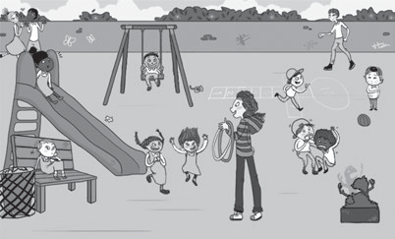
6
1
5
3
4
2

Look and write.
Pupils look at the pictures and write two sentences using the past simple and the present simple.

Answers
- Yesterday he was bored. Today he’s happy.
- Yesterday she was scared. Today she’s friendly.
- Yesterday he was worried. Today he’s happy.
- Yesterday she was excited. Today she’s friendly.

3 Write and draw about you.
Pupils describe themselves and draw their facial features and hair on the outlines of the two faces, then write two sentences about themselves using the past simple and the present simple.

Answers
Pupils’ own answers.

Unit 4 Reinforcement Lesson 2

1 Look, write and match.
Pupils look at the pictures and write the job on the line, using the word pool for reference. They then match the pictures on the left to the pictures on the right and complete the sentences for these pictures using the word pool for reference.

Unit 4 Reinforcement Lesson 6

1 Read and complete.
Pupils look at each picture and complete the gapped text, using the word pool for reference.

Answers
- professor 2 university 3 husband 4 daughter

Look and complete in the past tense.
Pupils look at the six pictures and complete the gapped text, using the word pool for reference

Answers
1 The family had breakfast together. 2 Mr Brown went to Oxford. 3 Mrs Brown met a friend. 4 Denzil won 1st prize at the dog show. 5 He became famous.
6 The family made pasta for dinner.

3 Write sentences that are true for you.
Pupils write sentences about their day yesterday.

Answers
Pupils’ own answers.

Unit 5 Reinforcement Lesson 2

1 Look and reorder the letters.
Pupils look at the pictures, identify the material the object is made of and write the word on the dashed line.

Answers
1 wool 2 cotton 3 glass 4 silk 5 wooden
6 rubber 7 metal 8 paper 9 leather 10 plastic

2 Order and write.
Pupils look at the pictures and unscramble the words to make a sentence.

Answers
1 A scientist has to wear plastic glasses. 2 A chef has to wear a paper hat. 3 Police officers have to wear belts. 4 A gardener doesn’t have to wear a jumper.
5 Lifeguards don’t have to wear socks.

3 Write sentences that are true for you.
Pupils complete sentences about their life.

Answers
Answers

1 He’s a musician. c He played the violin. 2 She’s a gardener. a She planted a tree. 3 She’s a computer programmer. f She played a computer game.
4 He’s a cook. h He cooked a pizza. 5 He’s a police officer. i He walked for 10 km. 6 She’s a firefighter. b She climbed a ladder. 7 He’s a scientist.
e He discovered a new medicine. 8 She’s an engineer. d She designed a bridge. 9 She’s an artist. j She painted
a picture. 10 He’s a journalist. g He talked to a celebrity.

2 Write sentences that are true for you.
Pupils complete the sentences so that they are true for them, using the word pool for reference.

Answers
Pupil’s own answers.
Pupils’ own answers.

Unit 5 Reinforcement Lesson 6

1 Complete the crossword.
Pupils look at the pictures and write the word in the crossword.

Answers
1 torch 2 rucksack 3 fire 4 whistle 5 map
6 blanket

2 Look, find and answer.
Pupils look at the picture and answer the questions.

Answers
1 Yes, he did. 2 No, she didn’t. 3 Yes, they did.
4 No, he didn’t. 5 Yes, she did. 6 No, they didn’t.

3 Answer the questions for you.
Pupils answer the questions about themselves.

Answers
Pupils’ own answers.

Unit 6 Reinforcement Lesson 2

1 Complete and match.
Pupils look at the anagrams and write the words. They then match the verbs to the pictures (a–j).

Answers
1 climb a mountain, g 2 go kitesurfing, b
3 take photos, c 4 go fishing, j 5 visit a castle, e
6 cook on the campfire, i 7 go to the beach, a
8 play volleyball, d 9 swim in the lake, h
10 go caving, f

2 Look and write.
Pupils look at the thought bubble and complete the text about the boy’s weekend.

Answers
1 Scotland 2 climb 3 take (some) 4 going to go
5 I’m going to 6 campfire 7 I’m going to go 8 go
9 (I’m going to) play

3 Look and write about Zoe’s weekend.
Pupils look at the notes and then write sentences about Zoe’s weekend.

Answers
At the weekend, Zoe is going to visit a castle. She’s going to swim in the lake. She isn’t going to climb a mountain. She isn’t going to go caving.

Unit 6 Reinforcement Lesson 6

1 Find, circle and write.
Pupils look at the pictures, find the food words in the wordsearch, then write them on the lines under the pictures.

Answers
1 customer 2 barbecue 3 menu 4 main course
5 waiter 6 waitress

2 Look and write.
Pupils look at the numbered characters in the large picture and answer the questions about them.

Answers
1 No, it isn’t. 2 Yes, he is. 3 Yes, she is.
4 No, he isn’t. 5 No, they aren’t. 6 No, she isn’t.

3 Choose ✔ activities and write what you are going to do on holiday.
Pupils look at the activities and write what they are going to do on their holidays.

Unit 1 Extension Lesson 2

1 Read and look. Complete the sentence.
Pupils read the sentences and then look at the timetable. They then complete the text and write the name of the activity.

Answers
- play football

Complete. Use the present simple or the present continuous.
Pupils look at the pictures and complete the sentences with the present simple or continuous.

Answers
1 He plays hockey on Saturdays. 2 She’s swimming now. 3 He’s doing archery today. 4 She plays table tennis every week. 5 She does gymnastics on Fridays. 6 He’s playing badminton this afternoon. 7 He goes
trampolining on Tuesdays and Thursdays. 8 She’s going abseiling today. 9 She’s going climbing / She goes climbing at school.

3 Write 4 sentences that are true for you. Use the words in the box.
Pupils write sentences about what activities they do. Ensure they choose correctly between the past simple and the past continuous.

Answers
Pupils’ own answers.

Unit 1 Extension Lesson 6

1 Complete the crossword.
Pupils read the gapped sentences and write the missing word on the leader line and in the crossword.

Answers
1 player 2 win 3 stadium 4 match 5 goal
6 team

2 Look and match.
Pupils look at the numbered children in the picture, read the answers and complete / write the questions.

Answers
1 Why are they cold? 2 Why are they thirsty?
3 Why is she scared?

3 Look and find these children. Answer.
Pupils look at the picture in Activity 2, find the children and answer the questions.

Answers
- Because she’s got an ice cream.
- Because he can’t play football.

Answers
Pupils’ own answers.

Unit 2 Extension Lesson 2

1 Look and answer.
Pupils look at the pictures and read the questions. They then write the answers.

Answers
1 The giraffe is taller than the camel. 2 The bear is heavier than the kangaroo. 3 The lion is faster than the elephant. 4 The snake is longer than the crocodile.
5 The monkey is slower than the zebra.

Look at the pictures of the lion and the tiger. Guess which animal is longer, heavier and faster.
Pupils look at the pictures and read the questions. They guess the answers.

Answers
Pupils’ own answers.

Read the text and answer the questions.
Pupils read the text and answer the comprehension questions.

Answers
1 The tiger is longer than the lion. 2 The tiger is heavier than the lion. 3 The lion is faster than the tiger.
4 The tiger is better at swimming than the lion.

Unit 2 Extension Lesson 6

1 Match the opposites.
Pupils match the opposite words by drawing a linking line.

Answers
1 fastest – slowest 2 shortest – tallest
3 weakest – strongest 4 best – worst

2 Look at the superheroes. Make sentences. Use the pictures to help you.
Pupils look at the information and pictures on the four trump cards. They then write sentences based on the word prompt at the beginning of each line.

Answers
1 Minnie is the oldest. 2 Max is the strongest.
3 Mowgli is the fastest. 4 Max is the best at flying.
5 Max is the tallest. 6 Mel is the cleverest.
7 Mowgli is the worst at kung fu.

3 Answer the questions about your class.
Pupils answer the questions about the children in their own class at school.

Answers
Pupils’ own answers.

Unit 3 Extension Lesson 2

Look, read and write the year.
Pupils read each sentence and look at the three pictures. They decide which picture(s) the sentence applies to and write down the relevant year(s).

Answers
1 1816, 1916, 2016 2 1816 3 1816 4 2016
5 1816 6 1916

Look and find the 6 differences. Then write.
Pupils look at the two pictures, find six differences and circle them. They then write six sentences about the differences.

Answers
[in any order]
1 Last year, there was a poster of an elephant. 2 Last year, there wasn’t a trumpet. 3 Last year, there were cuddly toys. 4 Last year, there was a table tennis bat. 5 Last year, there wasn’t a scarf. 6 Last year, there weren’t any football trophies.

3 What was different in your bedroom last year? Write 3 sentences.
Pupils think back to how their bedroom is different now from last year, and write three sentences about what used to be there.

Answers
Pupils’ own answers.

Unit 3 Extension Lesson 6

1 Look and complete.
Pupils look at the numbered children in the picture and write sentences about them, using the word pool for reference.

Answers
1 She was worried. 2 He was happy. 3 He was friendly.
4 She was bored. 5 They were excited.
6 They were scared.

2 Look and read. Then complete.
Pupils read the texts about the three children. Then they read about different scenarios and look at the pictures. For each one, they have to decide how each of the three children might feel about the scenario based on what they know about them. They write a sentence for each child.

Possible answers

1
Vicky was happy / excited. Jim was worried.
Peter was excited / happy.

2
Vicky was excited / happy. Jim was worried / scared. Peter was excited / happy. 3
Vicky was worried / scared. Jim was happy / excited.
Peter was happy / excited.

Unit 4 Extension Lesson 2

Label the pictures. Then find the odd one out and complete the sentence.
Pupils look at the pictures of the people doing various jobs. They then think of a reason why one of the people is different to the others. There are lots of possible answers, so encourage pupils to give reasons for their choice.

Answers
Pupils’ own answers.

Look and complete.
Pupils look at the pictures and complete the sentences, using the word pool as a reference.

Answers
- The gardener planted a tree.
- The journalist talked to a celebrity.
- The musician played the violin.
- The police officer walked for 10 km.
- The cook cooked a pizza.
- The engineer designed a bridge.
- The scientist discovered a new medicine.
- The firefighter climbed a ladder.
- The artist painted a picture.
- The computer programmer played a computer game.

3 Write sentences that are true for you.
Pupils write sentences about their day yesterday, using the word prompts.

3 Write sentences that are true for you.
Pupils write sentences that are true for them, using the word pool for reference.

Answers
Pupils’ own answers.

Unit 5 Extension Lesson 2

1 Look and complete.
Pupils look at the objects in the pictures and work out what materials they are made of. They then complete the sentences.

Answers
1 wool 2 plastic / metal 3 rubber 4 metal / plastic
5 wooden 6 leather 7 cotton 8 silk 9 leather

2 Look and write.
Pupils look at the pictures and write a sentence about what the person has to or doesn’t have to wear in their job, using the word pool for reference.

Possible answers
1 He has to wear a paper hat. 2 She has to wear plastic glasses. 3 He has to wear leather gloves. 4 They have to wear leather belts. 5 They don’t have to wear socks. 6 He doesn’t have to wear a jumper.

3 Write sentences that are true for you.
Pupils complete the sentences so that they are true for them.

Answers
Answers

Pupils’ own answers.

Unit 4 Extension Lesson 6

Complete the mind maps. Can you add any more words?
Pupils look at the words in the word pool and write them on the mini mind maps in the appropriate places. Then they look at the verbs in the mind map and write any more collocations they can think of.

Possible answers
make – a snowman, breakfast, a cake, a coffee, a picnic go – to the beach, to London
have – breakfast, a cake, a coffee, a toothache, a picnic meet – a friend, a doctor
win – a prize become – a doctor

Look and write sentences in the past tense.
Pupils look at the pictures and complete the sentences, using the word pool for reference.

Answers
1 The family had breakfast. 2 Mr Brown went to Oxford. 3 Mrs Brown met a friend. 4 The dog won a prize at a dog show. 5 He became famous. 6 The family made pasta for dinner.
Pupils’ own answers.

Unit 5 Extension Lesson 6

1 Complete the crossword.
Pupils read the clues and write the words in the crossword.

Answers
1 torch 2 rucksack 3 fire 4 whistle 5 map
6 blanket

2 Look, find and write the questions.
Pupils look at the picture and write questions that match the answers provided. In questions (4–6), there are multiple correct possible answers.

Answers
1 Did he make a fire? 2 Did she go hiking? 3 Did they get water? 4 Did he cook fish? / Did he get wood?
- Did she cook fish? / Did she go mountain biking?
- Did they go mountain biking? / Did they get wood?

3 Answer the questions for you.
Pupils answer the questions about themselves Pupils’ own answers.
Answers

Unit 6 Extension Lesson 2

1 Look and write.
Pupils look at the picture and complete the gapped text.
Answers
1 Scotland 2 climb 3 (I’m going to) take
4 going to go 5 I’m going to 6 campfire
7 I’m going to go 8 go 9 (I’m going to) play

Write about their holidays.
Pupils look at the table and write sentences about what the children are going to do on their holidays.
Answers
Jane is going to visit a castle, but she isn’t going to go caving. She’s going to swim in the lake. She isn’t going to take photos.
Lara and Fred aren’t going to visit a castle. They are going to go caving. They are going to swim in the lake. They aren’t going to take photos.

Answer the questions about your next holiday.
Pupils answer questions about their next holiday.
Answers
Pupils’ own answers.

Unit 6 Extension Lesson 6

1 Look and write.
Pupils look at the pictures and write the correct label under each picture.
Answers
1 customer 2 barbecue 3 menu 4 main course
5 waiter 6 waitress

2 Look and write short answers and sentences.
Pupils look at the picture and answer the questions with short answers. If the answer is negative, they also write a clarifying answer.
Possible answers
(NB There can be some flexibility on the clarifying sentences, as long as what your pupils write makes sense.)
- No, it isn’t. It’s sunny.
- No, he isn’t. He’s going to take photos.
- Yes, she is.
- Yes, he is.
- No, they aren’t. They’re going to eat dinner.
- No, she isn’t. She’s going to take photos.

3 Choose ✔ activities and write what you are going to do on holiday.
Pupils look at the activities and write what they are going to do on their holidays.
Answers
Pupils’ own answers.

