My daily routine worksheet year 4 teaching resources

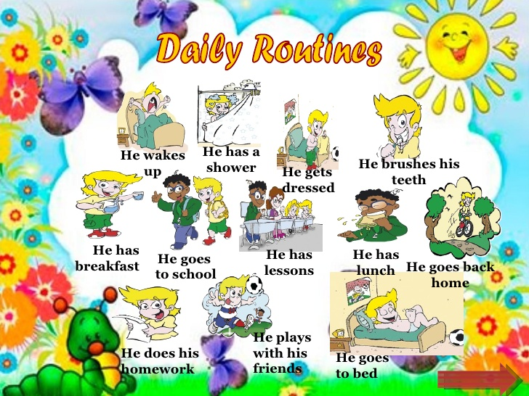

My daily routine. Write what time you usually do these things.

1. I normally wake up at .......................................................................

2. .I usually get up at............................................................................

3. I get dressed at................................................................................

4. . I have breakfast at.................................................................................

5.. I go to school at....................................................................by.................

6. I have lunch at................................................................................................

7. I go home at......................................................................................................

8. I have a snack at...........................................................................................

9. I always do my homework

10. I go to.................... classes on ........................and .......

11. I have dinner at..........................................................................................

12. I have a shower at....................................................................................

13. I go to bed at................................................................................................

