ENGLISH 5th: 15th June 2020

Watch the video:

https://www.youtube.com/watch?v=Gj6V-xZgtlQ

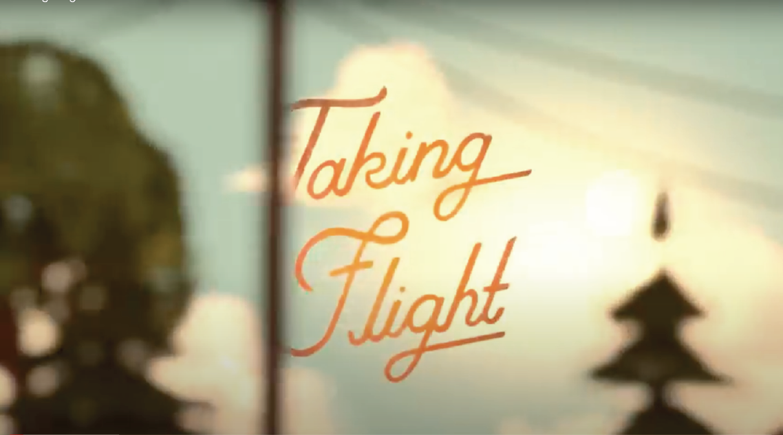

Have a great summer holidays

