ENGLISH 5th: 5th week, 3rd TERM
Imagine and draw about you and your family in an unusual situation:

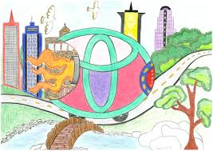

Write about your picture.

- Who is in your picture? I’m with…
- Where is it? We are in …
- What are you doing here? I’m doing…
- What are they doing? They are….
- Are there any..? There are some…

Remember the difference between: they are (ells són) / there are (hi ha)
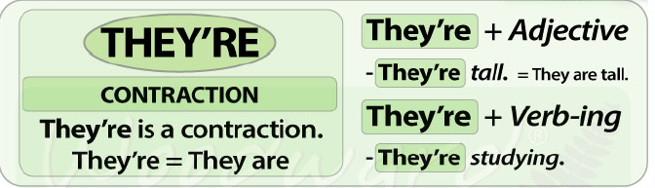

Show and explain your picture. Send it in a video to mferr366@xtec.cat

HAVE FUN!!!

