ENGLISH 5th: (25th May 2020)

The posters reflect some of the most common suggestions for calming down and staying healthy in times of stress:

- Drink water.
- Eat healthy food.
- Exercise.
- Get facts.
- Get fresh air.
- Get sunshine.
- Get rest.
- Keep in touch.
- Keep a journal.
- Keep a routine.
- Laugh.
- Limit your intake of news.
- Meditate.
- Listen to music.
- Practice a hobby.
- Relax.
- Take a walk.
- Do yoga.

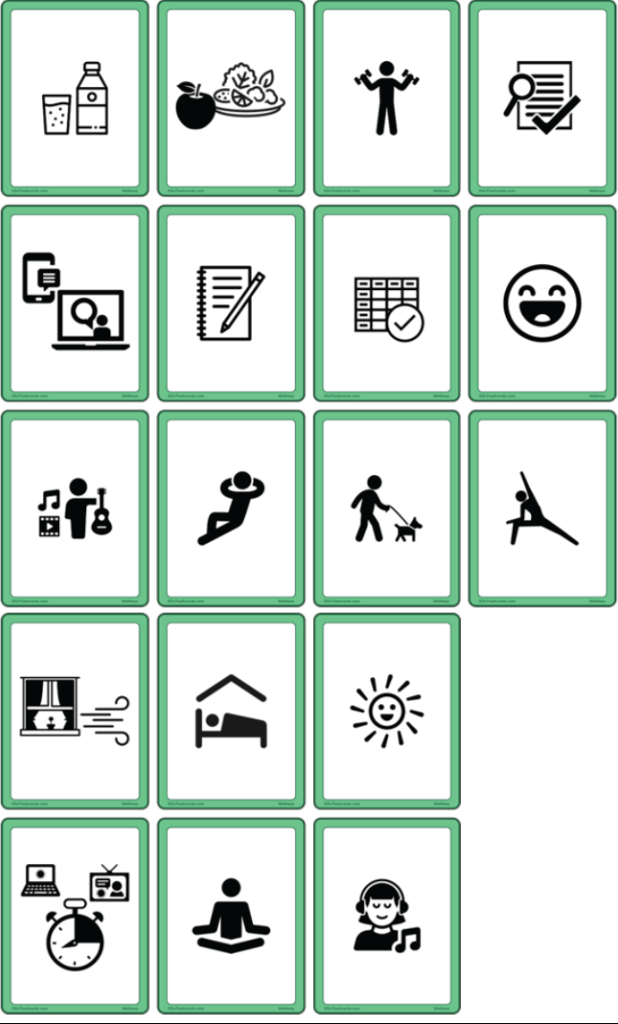

Make your own posters (image and text) and put/hang them in different parts of your house. Send photos with the result. (mferr366@xtec.cat)

