Name:

Look at this picture:

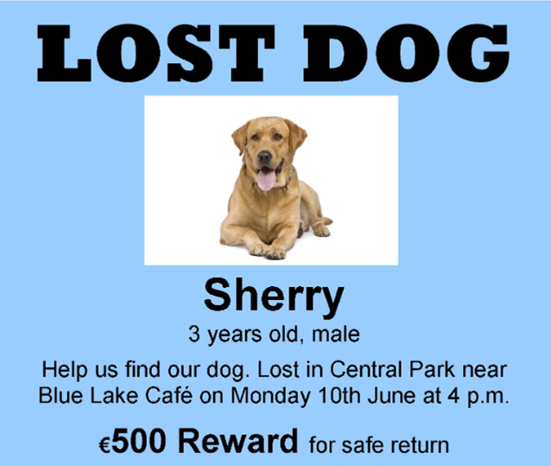

Vocabulary:

- Lost: perdut
- Reward: recompensa
- Male: masculí

1. Write T (true) or F (false)
1. The dog is lost ……….
2. The dog’s name is Sherry ……….
3. The dog is a female ……….
4. The dog was lost on Monday morning ……….
5. The dog was lost in Central Park ……….
6. There is a reward for finding the dog ……….

2. Complete:

- Dog’s name

- Age

- Date dog was lost

- Time dog was lost

- Place dog was lost

- Money offered for finding dog

euros.

3. Correct the mistakes.

1. The dog is called Berry.
The dog is called .

2. The dog is five years old.
The dog is years old.

3. The dog was lost on Tuesday.
The dog was lost on .

4. Sherry is a female dog
Sherry is a dog.

5. Sherry was in Central Café
Sherry was in .

