Name:

SPORTS STAR

1. Order the letters:

- IDRE A EKIB

RIDE A BIKE

- OD ODJU

- ORW

- EDIV

- AYPL BLETA NNSITE

- CEI KASTE

- OD RTEKAA

- IDER A RSEOH

- LLEBRALDEOR

- KATSEOABRD

2. What can you do?

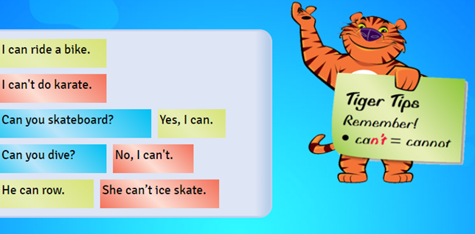

Remember...

- I can do judo → Affirmative

- I can’t do judo → Negative

- What can you do?

Example:
- I can do karate.
- I can’t play table tennis.

3. Draw.

MY FAVOURITE SPORT

