NAME:

- Look at this poster:

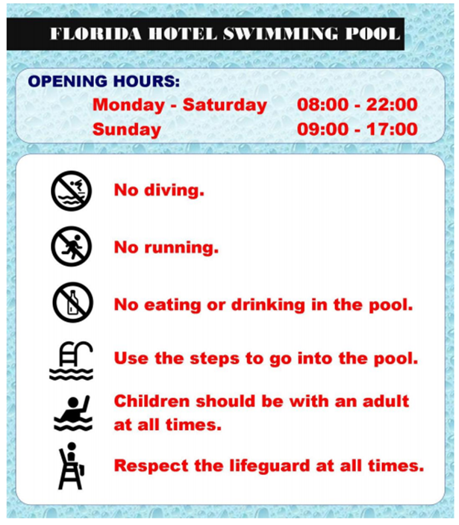

Vocabulary:
- Lifeguard: socorrista

- Match the word to the correct picture

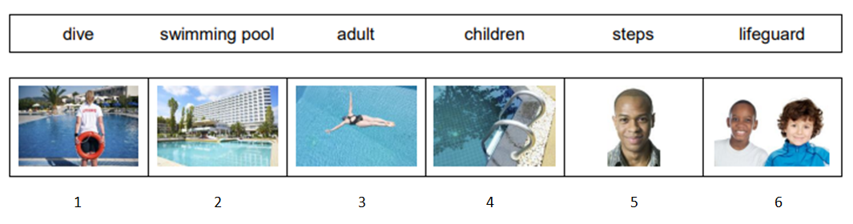

PICTURE | WORD
1
2
3
4 | STEPS
5
6

- What do you do at the swimming pool? Write the verbs in the correct group.

At the swimming pool, do... | At the swimming pool, don’t...

- Write T (true) or F (false).

- The swimming pool is open every day. ………
- The swimming pool is open at 8:00 on Sunday. ………
- You can eat in the pool. ………
- Children can swim alone. ………
- You can’t dive into the pool. ………
- The swimming pool closes early on Sunday. ………

- Is there a swimming pool in your town?

