Name:
POPCORN SCIENCE EXPERIMENT
“Popcorn weighs more or less after making it? What do you think about it? Investigate with this experiment!”

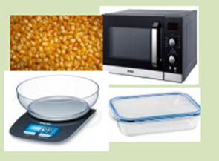
MATERIALS
- Unpopped popcorn
- Microwave
- Bascule
- Microwave container

INSTRUCTIONS
- Weigh 15-30 units of popcorn in a bascule
- How much do your unpopped popcorn weigh? Write the weight of the popcorn.
- Put the popcorn inside the microwave during 2-3 minutes.
- Weigh the cooked popcorn.
- How much do your cooked popcorn weigh? Write the weight of the popcorn.
CONCLUSION
Choose one option: more or less.
Popcorn weighs after making it.

Draw your favourite part of the experiment.

