SPORTS STAR

VOCABULARY
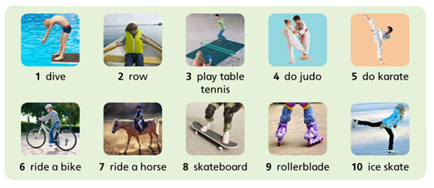
(Pupil’s book page 21)

Games: https://tiger.macmillan.es/

Enter your password! Remember: it is on the inside front cover of the Activity Book.

Unit 3 Sports Star: you can play vocabulary games.

MORE GAMES AND SONGS:

- https://learnenglishkids.britishcouncil.org/word-games/sports-1
- https://learnenglishkids.britishcouncil.org/songs/i-can-run
- https://www.youtube.com/watch?v=tgUSHk6JaTY

Do you like these games?

Do you like these songs?

