Name: Date:

ANIMAL WORLD

- Look and match.
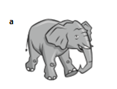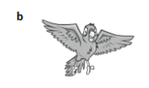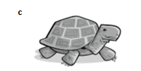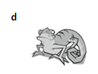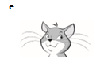

- It’s got big ears. ……….
- It’s got whiskers. …e……
- It’s got wings. ……….
- It’s got a shell. ……….
- It’s got a long tail. ……….

- Look and write the words.

Green
Lizard

- Describe two animals. Use ‘s got and hasn’t got.

Example:
CAT
It’s a mammal. It’s got long whiskers, two eyes and two ears. It hasn’t got a shell. It’s got four legs and a long tail. It’s very fast.

………………………….

…………….……………………………………………………………………………
…………….……………………………………………………………………………
…………….……………………………………………………………………………
…………….……………………………………………………………………………
…………….……………………………………………………………………………
…………….……………………………………………………………………………

………………………….

…………….……………………………………………………………………………
…………….……………………………………………………………………………
…………….……………………………………………………………………………
…………….……………………………………………………………………………
…………….……………………………………………………………………………
…………….……………………………………………………………………………

