Name: Date:

DESCRIBING PEOPLE

- Look and write T (true) or F (false).

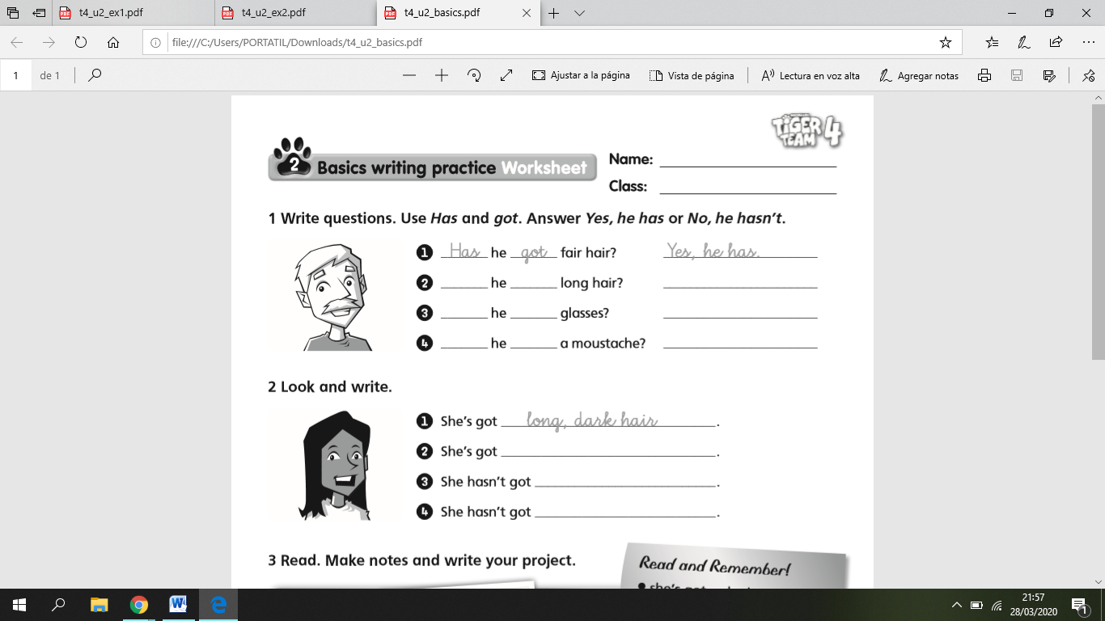

- He’s got fair hair. ……….
- He’s got long hair. ……….
- He’s got dark hair. ……….
- He’s got a moustache. ……….
- He’s got curly hair. ……….
- He’s got a beard. ……….

- She’s got glasses. ……….
- She’s got a beard. ……….
- She’s got long hair. ……….
- She’s got curly hair. ……….
- She’s got short hair. ……….
- She’s got dark hair. ……….

- Look and write the words.
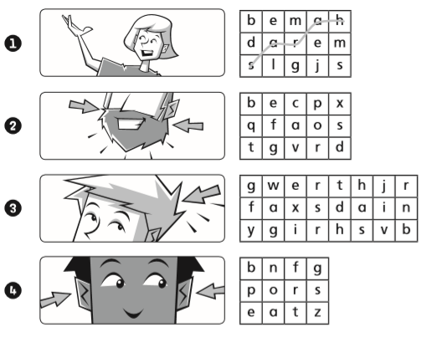


………………………….

………………………….

………………………….

- Look and write what she looks like. Use ‘s got and hasn’t got.
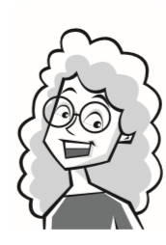

She’s got ……………………………………………………………………………
…………….……………………………………………………………………………
…………….……………………………………………………………………………
…………….……………………………………………………………………………
…………….……………………………………………………………………………
…………….……………………………………………………………………………

