Hello everybody! Here you have a really interesting reading about arboreal animals and plants. Do you know what’s this? Read the following text and answer the questions to find out more about this topic! There is a small quiz too if you want to keep learning!

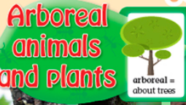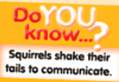

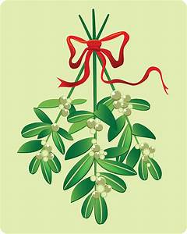
1
This is mistletoe. It grows on tree branches. The plant is a parasite. It takes water and nutrients from the tree. But mistletoe is important because many birds and mammals eat it.
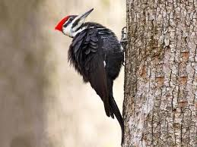
2

This bird is called a woodpecker because it pecks tree trunks. It makes holes in the trunk. Its babbles live in the hole. Woodpeckers eat insects that live in trees.

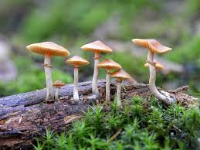
3

Some mushrooms grow on the trunks, but don’t eat them. Some of them are poisonous.
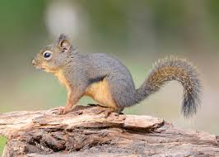
4

Squirrels live in nests in trees. They build their nest high in the tree for protection from predators. Their favourite food is nuts.
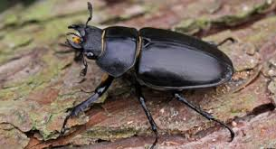
5

These beetles lay their eggs in dead trees. When the larvae are born, they eat the dead Wood.

1- Answer:
- Which photos show a mammal, a fungus, a bird, an insect and a plant?
- Which animal eat dead wood?
- Which animal eat insects?
- Why is mistletoe important?
- Where do some mushrooms grow?
- Which animal eat nuts?

2- Can you answer the following Quiz about ARBOREAL HABITATS?
