[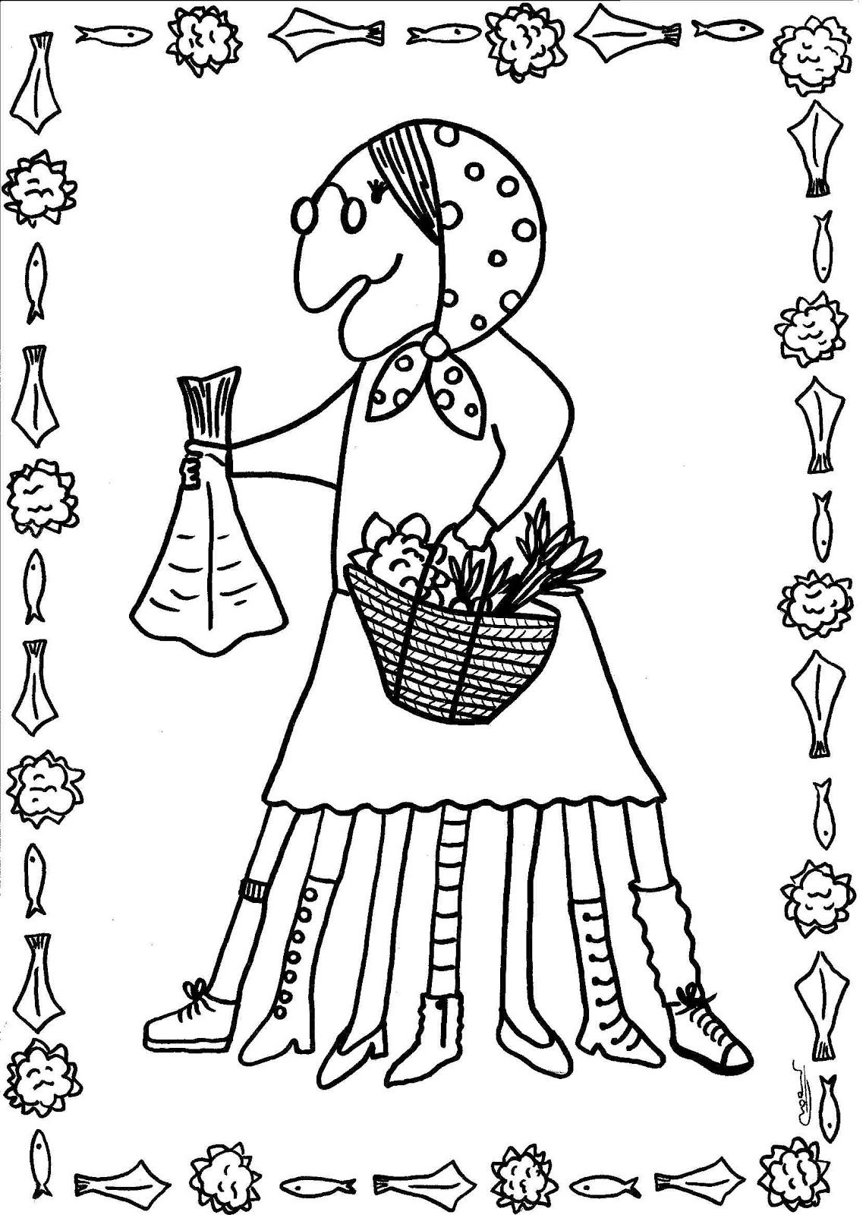](https://www.google.es/url?sa=i&url=https%3A%2F%2Fwww.pinterest.it%2Fpin%2F512354895083899894%2F&psig=AOvVaw2j2JB80ahjp7skQwZ9Ed-O&ust=1585387357728000&source=images&cd=vfe&ved=0CAIQjRxqFwoTCNDik6-quugCFQAAAAAdAAAAABAK)