[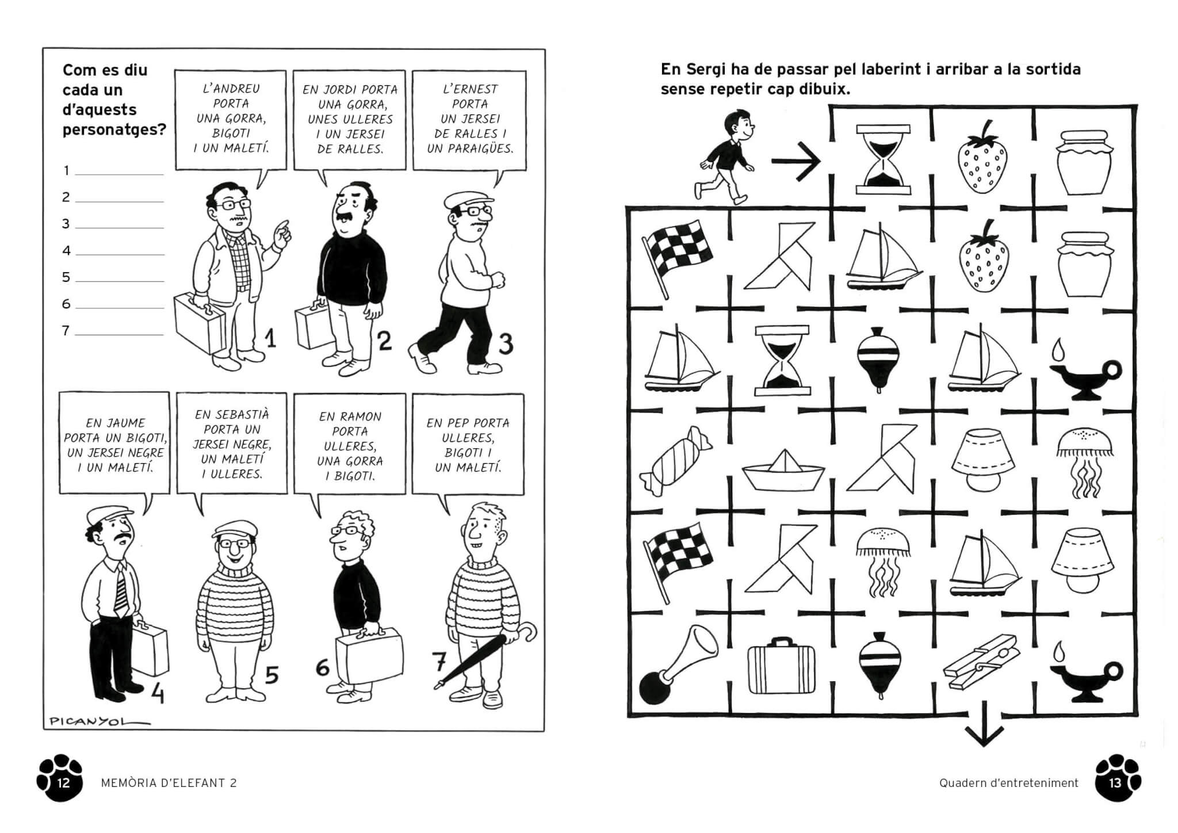](https://www.google.es/url?sa=i&url=https%3A%2F%2Fwww.edicionsdelpirata.cat%2Fproducte%2Fquadern-estiu-picanyol%2F&psig=AOvVaw21Ydhm7zBRPZgAHH8ahmzI&ust=1585304729160000&source=images&cd=vfe&ved=0CAIQjRxqFwoTCMjittD2t-gCFQAAAAAdAAAAABAK)