ENGLISH
#stayathome
#everythingwillbeok
#wemissyou
Name:
Level:
Date:

It’s almost the last week! I’m sure you are all very excited, so today we are going to do something fun! Do you know the Kahoot! platform? It’s a web page where you can play English challenges.
You don’t need to register, just go to https://kahoot.com/schools-u/ and click ‘play’:
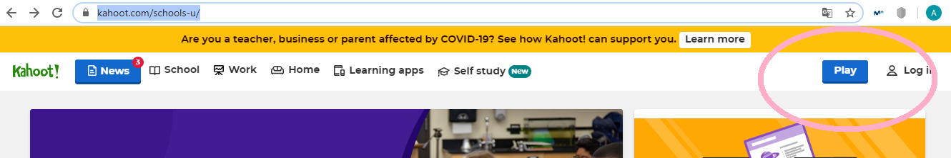

Here you will be asked to write the PIN for the activities.
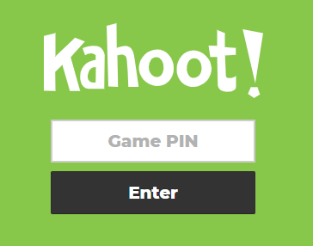

PIN 1: 06645153
PIN 2: 05898126

If you can’t enter with the PIN, try this URLs:
https://kahoot.it/challenge/06645153?challenge-id=58fc08cb-46e9-42b8-9535-4004f33d7c93_1591864981720
https://kahoot.it/challenge/05898126?challenge-id=58fc08cb-46e9-42b8-9535-4004f33d7c93_1591865666968

You can complete these Kahoots until next Thursday 18th June at 12:00am. I hope you have a great time and you learn a lot! And, remember, I can see your results!

