ENGLISH
#stayathome
#everythingwillbeok
#wemissyou
Name:
Level:
Date:

Do you remember the places in town? Let’s do a little review about the different buildings we can find!

- Look at the pictures and choose the correct answer:

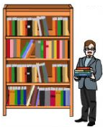  If you want to borrow a book, you must go to the:  - Bookstore  - Library  - Museum | If you want to have a little fun in the water, you can go to the:  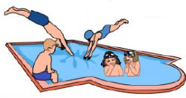  - School  - Bank  - Swimming  pool
If you’d like to enjoy a good meal, go to the:  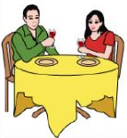  - Restaurant  - Farm  - Clothes shop | To see domestic animals, go to the:  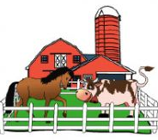  - Supermarket  - Farm  - Zoo
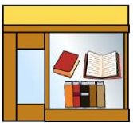  If you’d like to buy a new book, go to the:  - Theatre  - Bookstore  - Church | Children are educated and learn new things at:  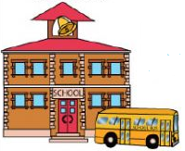  - The hotel  - The toy shop  - School
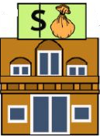  If you want to get money, go to the:  - Bank  - Boutique  - Church | 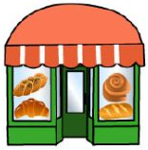  If you’d like to buy some cakes, go to the:  - Farm  - Clothes shop  - Bakery
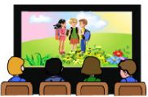  If you’d like to watch a movie, go to the:  - Park  - Theatre  - Cinema | 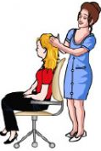  To get your hair cut, go to the:  - Hospital  - Hairdresser  - Bakery
To buy food and other things for the house, go to the:  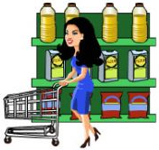  - Supermarket  - Candy shop  - Restaurant | If you need a little recreation, go to the:  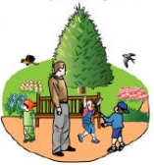  - Factory  - Park  - Library
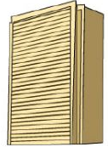  If you are a tourist, go to the:  - Farm  - Bakery  - Hotel | 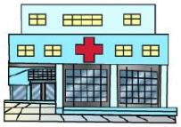  If you need medical treatment, go to the:  - Hospital  - Restaurant  - Museum
To buy some new clothes, go to the:
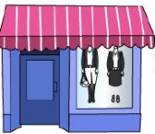
- Park
- Hairdresser
- Clothes shop

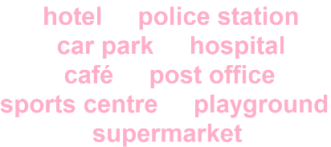
- Look at the map. There are some buildings that are missing the names. Read the text and write the name on each place.

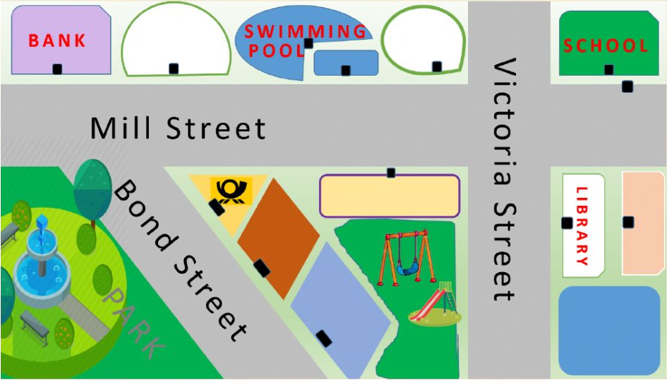

Greentown is a nice small town. There are so many things to do there. You can go for a walk in the park. There is a nice park in Bond Street. Opposite the park there is a post office.
There is a hotel next to the post office. The hotel is between the post office and the police station.
There is also a playground. The playground is behind the police station. You can buy things at the supermarket. It’s next to the playground.
You can also go swimming. There is a big swimming pool in Mill Street. There is a café in front of the swimming pool.
The toy shop is opposite the supermarket. You can buy nice toys here.
You can play different sports at the sports centre. The sports centre is between the swimming pool and the bank.
The library is in Victoria Street. It’s in front of the hospital. You can park your car next to the hospital and the library. There is a big car park here.

- Look at the map and complete the sentences with opposite, next to, behind, between and in front of:

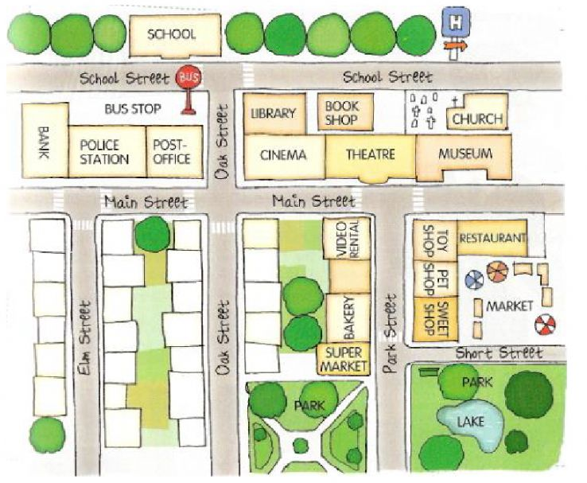

- There is a pet shop __________ the toy shop and the sweet shop.
- There is a market __________ the restaurant.
- The bus stop is __________ the post office.
- The restaurant is __________ the toy shop.
- There is a park __________ the supermarket.
- The museum is __________ the restaurant.
- The bakery is __________ the supermarket, __________ the sweet shop.
- The bookshop is __________ the theatre.
- The police station is __________ the bank and the post office.

