ENGLISH
#stayathome
#everythingwillbeok
#wemissyou
Name:
Level:
Date:

WHAT I CAN DO

- What can they do? Write the name of the activities:
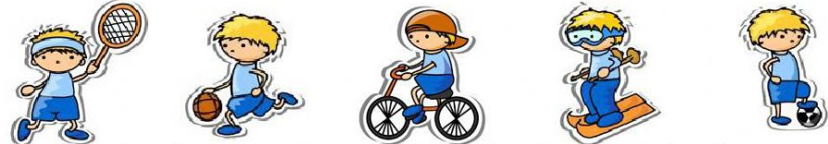

Play tennis __________ __________ __________ __________

__ ________ __________ __________ __________ __________

- Unscramble the words:

NTESNI __________
TABOLOLF __________
GLYNCIC __________
CETIHATLS __________
ISNIKG __________
GINUNRN__________
LABELSAB __________
FURSGIN __________
KESTALBABL __________
MIMSIWNG __________

- Can or can’t?

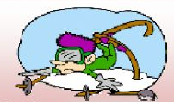  Adam _____ ski. | I _____ play basketball.
He _____ play the guitar. | 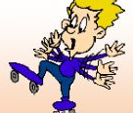  You _____ rollerblade.
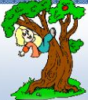  She _____ climb trees. | 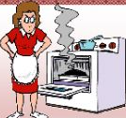  Alice _____ cook.

