ENGLISH
#stayathome
#everythingwillbeok
#wemissyou
Name:
Level:
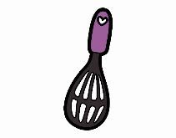
Date:

LITTLE CHEFS

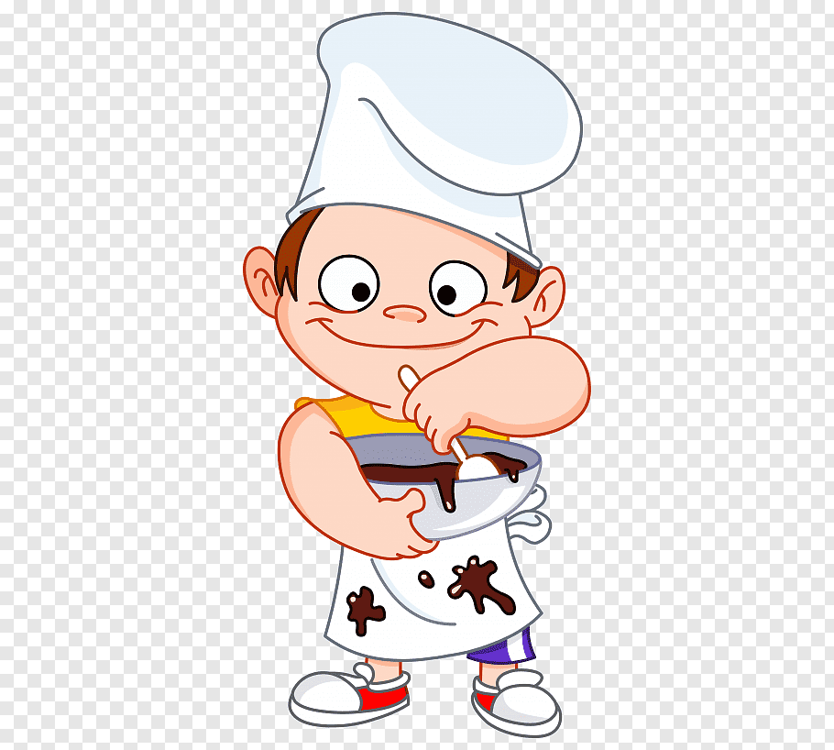
This week we are going to imagine we are little chefs and we’ve got a Youtube channel. In this channel, we post our delicious recipes, explaining the ingredients we use, the process we follow and all our tips for cooking the tastiest food… yummy!

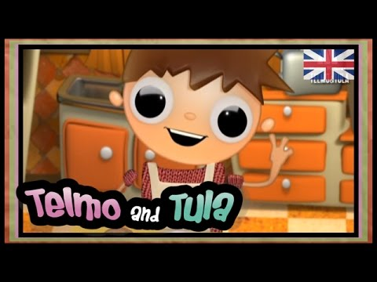
First, watch this video. Telmo and Tula are two brothers that love cooking and they prepare delicious recipes. Today, they are going to cook some pancakes with different toppings.

https://www.youtube.com/watch?v=APwKkdxbvpE

As you may have guessed, what I want you to do in this week’s task is to learn the parts of a recipe and do as Telmo and Tula and record a video cooking a delicious recipe of your choice.
But before cooking, there is a vocabulary about kitchen utensils you need to know:

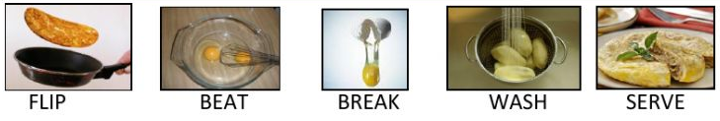
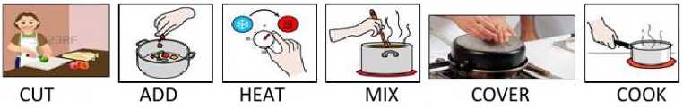

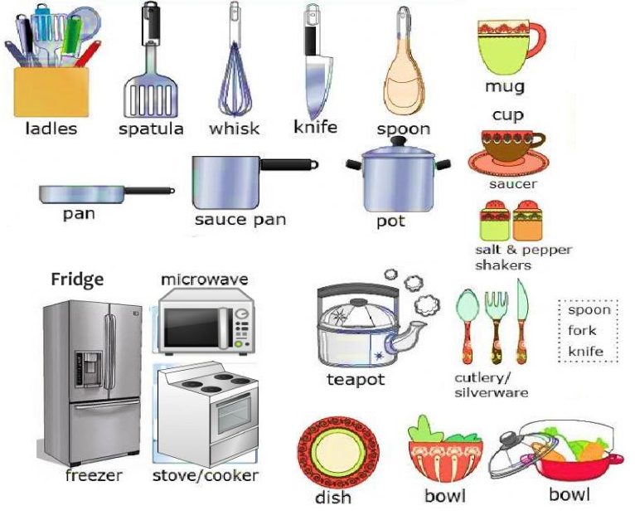

- Match the word with the definition:

- Stir | - To gently drop small pieces of something over a surface.
- Bake | - To move a soft substance across a surface so that it covers it.
- Sprinkle | - To cook something such as bread or a cake in an oven.
- Spread | - To mix food or liquid by moving a spoon round and round in it.

When you start cooking something, the first thing you need is the ingredients. In this case, Tula and Telmo are cooking pancakes. Do you remember what the ingredients are?

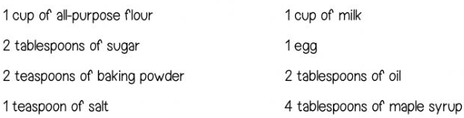

- Now, write the name of the ingredients under the right picture:

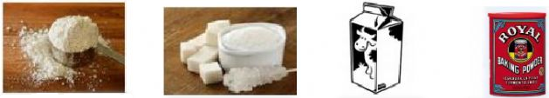

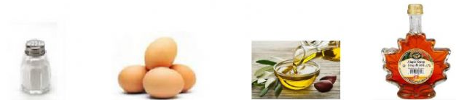

- Sometimes we measure the ingredients in grams and sometimes we use a cup, tablespoon or teaspoon. Write the name under each picture:

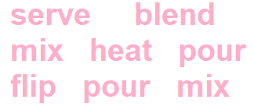
- Now we are ready to begin. As you know, we must follow several steps when cooking. These steps are a bit messed up, could you order the recipe and write the missing words?

- _____ with maple syrup! Enjoy!
- _____ it all together and then make a well in the centre.
- _____ the batter until it’s smooth.
- _____ a frying pan over a medium heat and lightly oil it.
- _____ in the batter and cook it for about 1-2 minutes (until lots of tiny bubbles start to appear and pop on the surface).
- _____ the pancake over and cook for another minute on the other side.
- _____ in the milk, the beaten egg and the oil.
- In a large bowl, _____ the flour, the sugar, the baking powder and the salt.

- Look at the pictures and write the superlative. Use these words:
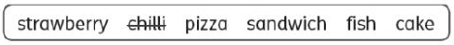
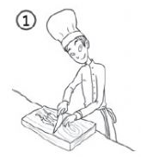
(hot)
This chili is the hottest.

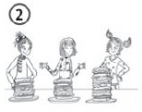
(big)
This cake is…

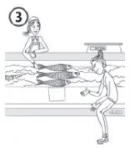
(long)

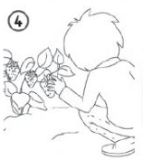
(big)

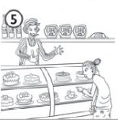

(small)

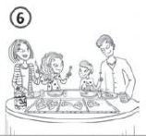
(good)

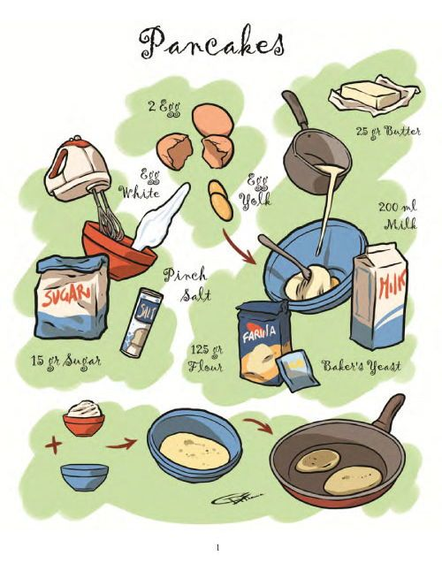
Now you are ready to make you own recipe! Fill the template you can find attached and upload it to Drive until the 27th May so I can correct it. Once the recipe is okay, you can film yourself cooking the recipe and upload the video until the 3rd June.
Imagine you are going to upload it to your Youtube channel, like Telmo and Tula, and lots of people will be watching, so use your imagination and enjoy!

- Before recording the video: write down your recipe!

- You need to find the recipe you like. It is very important! This is going to be the ‘Recipe name’. For example, I am going to cook a ‘Delicious banana bread’.
- Write the name of the chef (students name). In my case, it’s Anna.
- How many people can eat your recipe? Mine is for 4 or 5 persons. You have to write it in ‘Serves’. It is especially important because you need to know if there will be enough for everybody! No one wants to be hungry.
- Prep time: how much time do you need for preparing and cooking this delicious dessert? I think my banana bread needs 10 minutes of preparation and 20 minutes of baking.
- What ingredients do you need? Make a list with the ingredients and the quantities. I measured my recipe in grams, but you can also measure in cups, spoons… It’s up to you, it’s your recipe!
- Finally, you must give the directions for cooking this delicious dessert. What are the steps that you need to follow?
- And, of course, add a picture of your dish! We want to see its fantastic look! Yummy!

