ENGLISH
#stayathome
#everythingwillbeok
#wemissyou
Name:
Level:
Date:

HUMPTY DUMPTY

Do you know Humpty Dumpty? It’s an immensely popular English song about an egg. What happens to this egg? Let’s find it out! Watch the video and listen to the song! If you feel brave enough, you can also sing it!
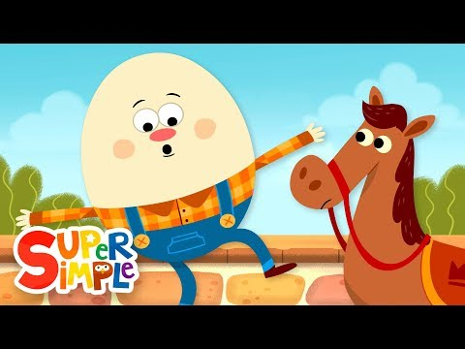
https://www.youtube.com/watch?v=nrv495corBc

Listen to the song again and fill the gaps with these words: fall, again, men, wall.

Humpty Dumpty sat on a __________,
Humpty Dumpty had a great __________,
All the king's horses and all the king's __________,
Couldn't put Humpty together __________.

Order the pictures according to the story

He sits on a wall | He has a great fall
The king’s horses and the king’s men | They can’t put Humpty together again
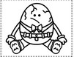

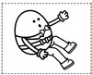
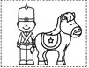

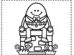

Humpty Dumpty is a rhyme. If a word rhymes with another word, the end part of the words sound the same:
‘Humpty Dumpty sat on a wall,
Humpty Dumpty had a great fall’.

Wall and fall sound the same. Can you do a short rhyme (two lines) about anything you want? For example:
I like the Moon
Because it looks like a balloon
The end parts of moon and balloon sound the same. Make your own rhyme!

Now you can cut and colour your Humpty Dumpty
