ENGLISH
#stayathome
#everythingwillbeok
#wemissyou
Name:
Level:
Date:

A GLASS OF MILK

Do you know how important a glass of milk can be? Watch this video and find it out…

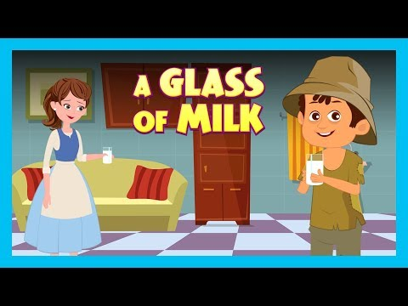
https://www.youtube.com/watch?v=aTi5dbVmUhU

Now, you are ready to answer these questions about the story!

- Where are Tia and Tofu?
- At school
- In the cinema
- In the park

- The boy loses his…
- Phone
- Parents
- Video games console

- Tofu says they are going to…
- Find the boy’s parents
- Miss the start of the movie
- Buy some popcorn

- What does odd mean?

- Why does the girl give the boy a glass of milk instead a glass of water?

- Why is the woman worried in the hospital?

- How does the woman pay the hospital bill?

- Why do you think it is important to help others?

