ENGLISH
#stayathome
#everythingwillbeok
#wemissyou
Name:
Level:
Date:

Do you remember the places in town? Let’s do a little review about the different buildings we can find!

- Match the buildings with their names:

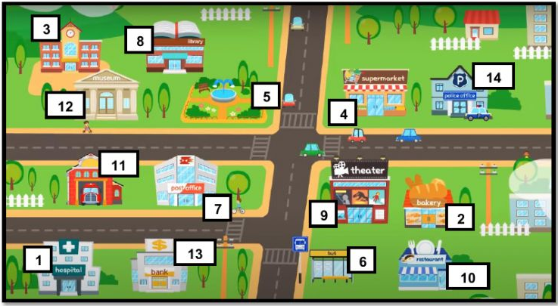

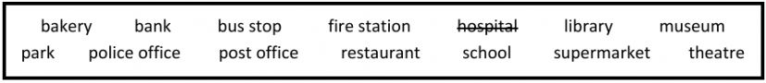

1 – Hospital 8-
2- 9-
3- 10-
4- 11-
5- 12-
6- 13-
7- 14-

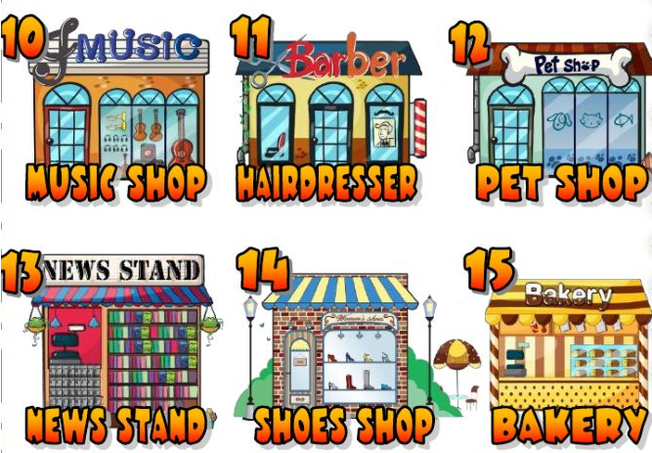
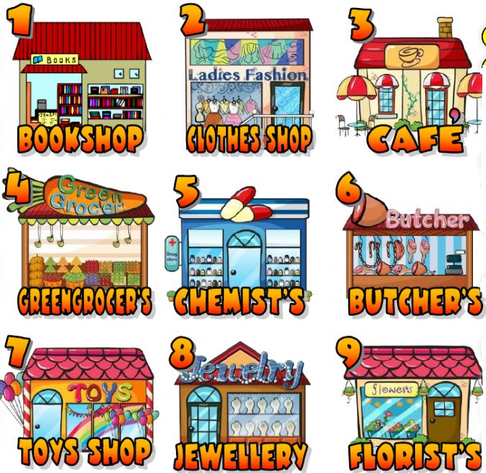
- Read the sentences and write the number of the shop. Where can I…

- buy a guitar?
- buy some pills?
- have a haircut?
- buy cat food?
- buy a flower?
- buy some bread?
- buy a magazine?
- buy a novel?
- buy a pair of
boots?
- buy a kite?
- buy an apple?
- buy some meat?
- buy a necklace?
- buy a skirt?
- buy a coffee?
- buy a ball?
- buy some
chicken?
- buy a cake?
- buy some
carrots?
- buy a T-shirt?
- buy a trumpet?
- buy the
newspaper?

To say that something exists (or doesn’t exist).

- Affirmative:

- Negative:

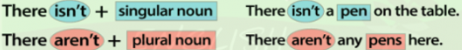

- Questions:

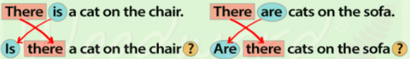

- Look at the map and write There is, There are, There isn’t, There aren’t:

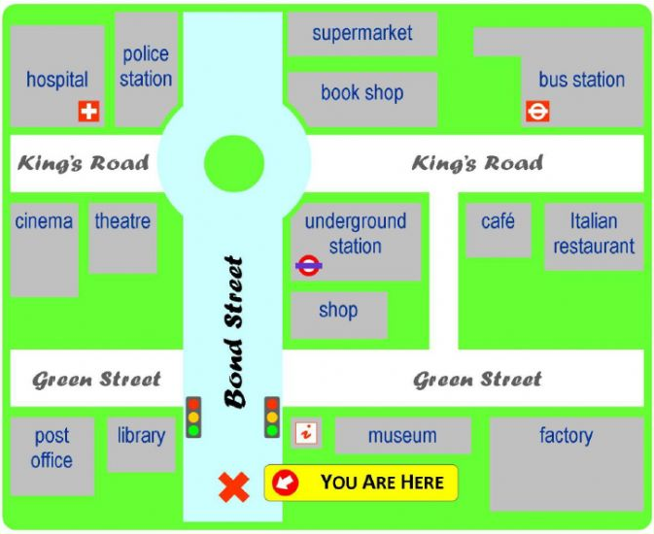

- __________ a museum next to the factory.
- __________ a theatre behind the library.
- __________ a post office next to the library.
- __________ any parks on Green Street.
- __________ two stations in this city: the underground station and the bus station.

- Look again at the map and answer Yes, there is, No, there isn’t, Yes, there are or No, there aren’t:

- Is there a shopping centre?
- Is there a hospital?
- Are there any shops?
- Is there a fire station?
- Is there a swimming pool?
- Is there a zoo?
- Is there a park?
- Are there any museums?
- Is there a library?
- Is there a train station?
- Are there two cafés?

